Data Structure Analysis and Algorithm

Unit – 1

Q1. What is algorithm? What does an algorithm do?

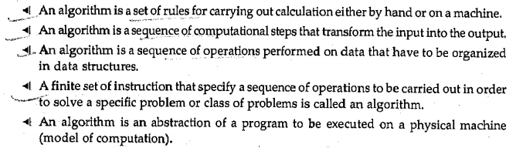

Q2. What are the criteria all algorithm must follow?

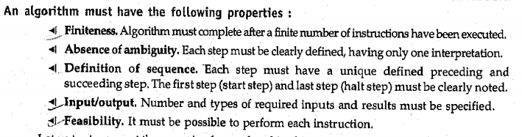
Q3. What are characteristics of an algorithm?

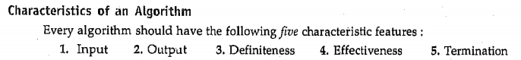
Q4. What are some Algorithm Design Techniques?

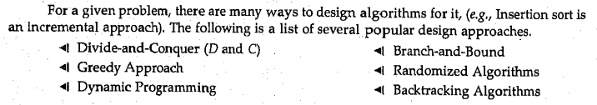

Q5. What is analysis of algorithm?

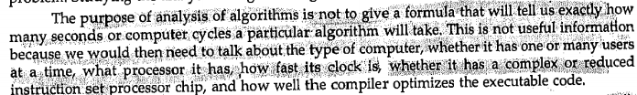
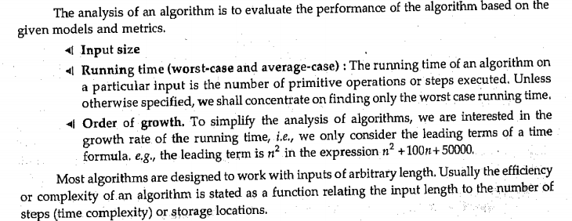
Q6. Name Some Computational Models?

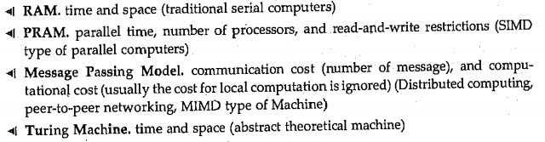
Q7. What is Formal and Informal Algorithm?

Formal Algorithm Analysis involves the use of mathematical methods and rigorous proofs to analyze the time and space complexity of an algorithm. It focuses on worst-case, average-case, and best-case scenarios using Big-O, Big-Ω, and Big-Θ notations. This method is theoretical and abstract, providing precise complexity bounds. Formal analysis is essential for proving the efficiency and correctness of algorithms under various conditions, but it may require a deep understanding of mathematical principles.
Informal Algorithm Analysis is more intuitive and practical. It involves estimating an algorithm's performance based on experience, experimentation, and general observation without detailed mathematical proof. Informal analysis often includes testing the algorithm on different input sizes and scenarios to determine its behavior in real-world settings. It provides a quick understanding of an algorithm’s efficiency, but the results are less precise compared to formal methods.
Q8. What is the difference between an algorithm and a program?
The difference between an algorithm and a program lies in their definitions and roles in problem-solving:
- Algorithm: It is a step-by-step, well-defined set of instructions to solve a problem. Algorithms are abstract concepts and independent of any programming language or implementation. They focus on logic and approach, not how the solution is carried out in a machine.
- Program: A program is the concrete implementation of an algorithm in a specific programming language that a computer can execute. It includes detailed instructions that a machine can follow, considering real-world constraints like memory, performance, and syntax.
In short, an algorithm is a plan, while a program is its translation into executable code.
Q9. What is RAM Machine?
A RAM (Random Access Machine) is a theoretical model used to design and analyze algorithms. It simulates a real computer by assuming an idealized machine with an infinite memory and a central processing unit (CPU) capable of executing basic instructions in constant time. The key features of the RAM model include:
- Instructions: The machine can perform basic operations like arithmetic, comparison, and data movement between memory and registers.
- Memory: It has an infinite amount of memory, where each memory location can be accessed directly in constant time (hence "random access").
- Time Complexity: Each instruction takes a fixed amount of time, simplifying the analysis of algorithms.
The RAM machine is used in algorithm analysis to focus on logical steps without worrying about hardware limitations, making it useful for theoretical studies.
Q10. What is Order of Growth of Function?

Order of Growth describes how the runtime or space requirements of an algorithm increase as the input size grows. It focuses on the dominant factor, ignoring constants and lower-order terms. This helps classify algorithms by efficiency, such as O(1), O(n), O(n²), etc. Understanding this is crucial in analyzing the performance of algorithms for large datasets, especially in tech-driven countries like India, where optimizing software for scalability is vital.
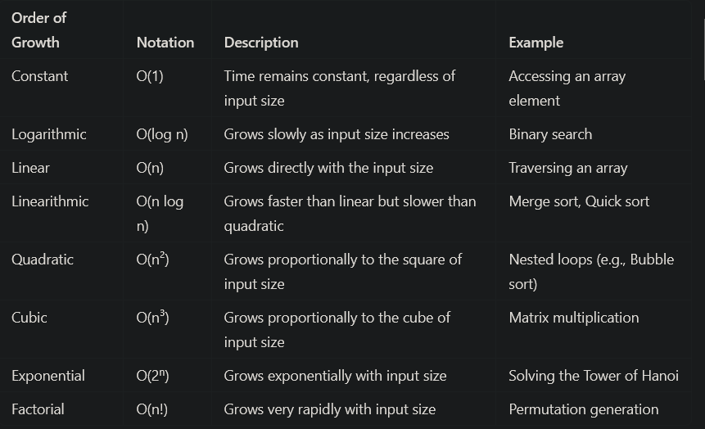

Q11. What is Growth Rate of Function?

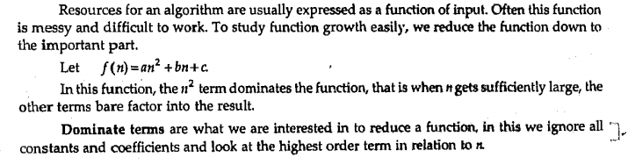

Q12. What are Asymptotic notation? Write down its 5 types.

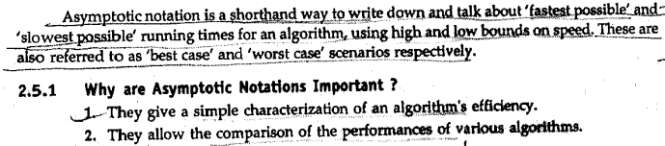

Q13. Explain Big-Oh Notation with graph and example.
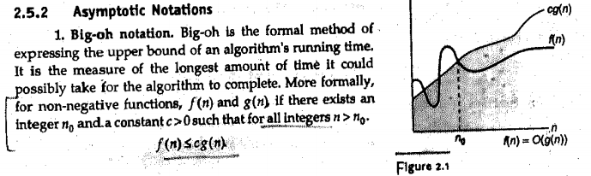
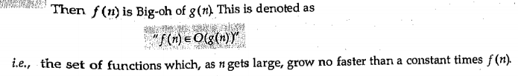
Q14. Explain Big-Omega Notation with graph and example.
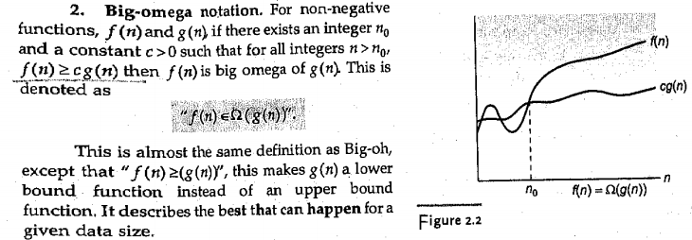

Q15. Explain Big-Theta Notation with graph and example.
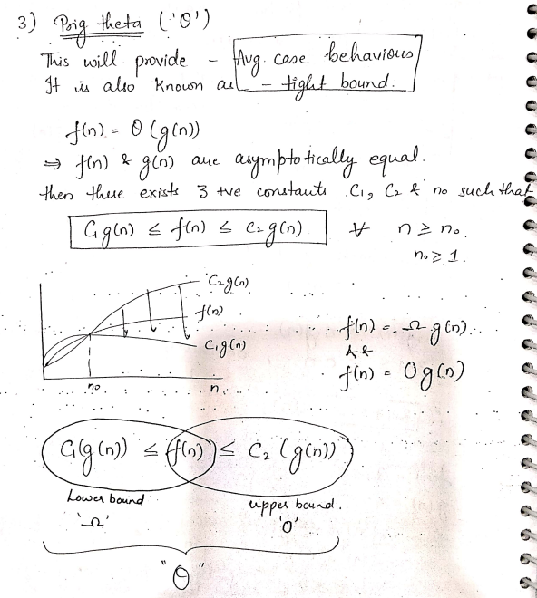
Q16. Explain Little-Oh Notation with graph and example.

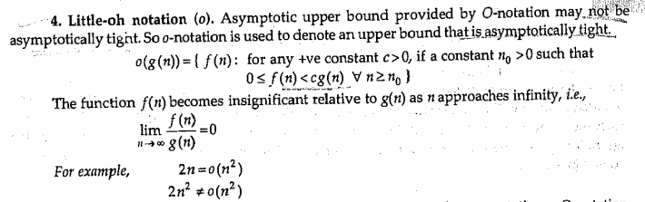

Q17. Explain Little-Omega Notation with graph and example.

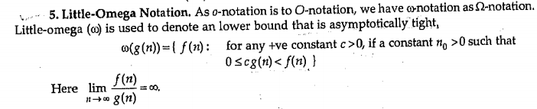
Q18. Give Relation Between Asymptotic notation.

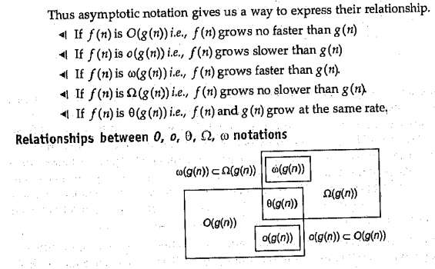

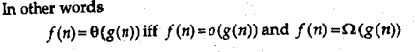

Q19. What is a recurrence relation?

A recurrence relation is an equation that recursively defines a sequence of values, where each term is defined in terms of one or more preceding terms. It is often used in algorithm analysis to describe the time complexity of recursive algorithms.

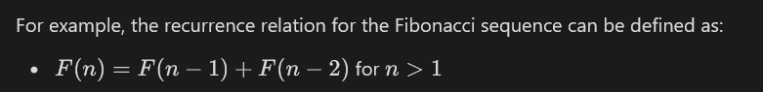

Q20. Explain Substitute Method.

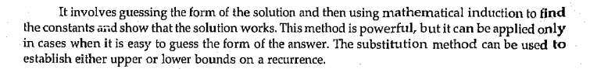

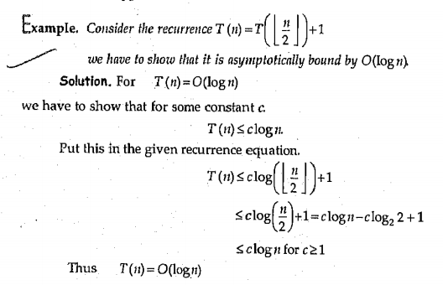

Q21. Explain Internation Method.

Q22.
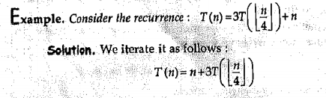

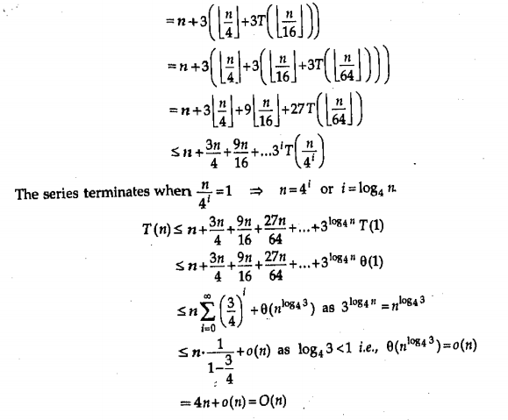
Q23.

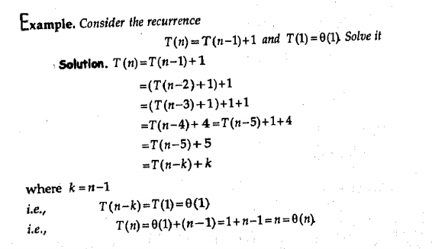
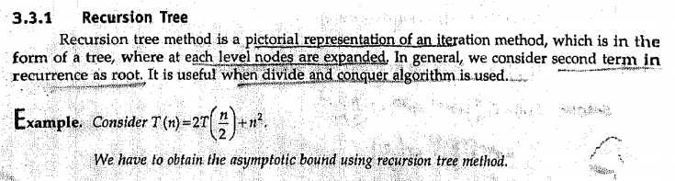
Q24. What is Recursion Tree?

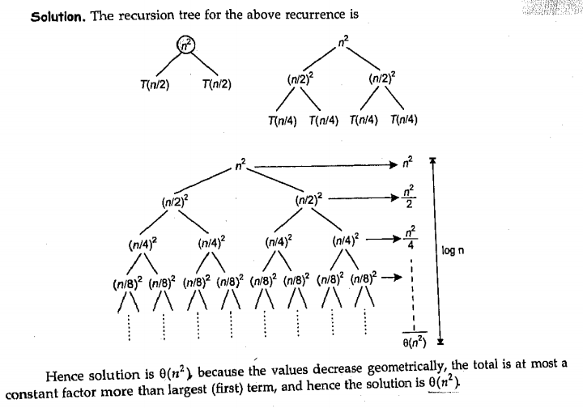

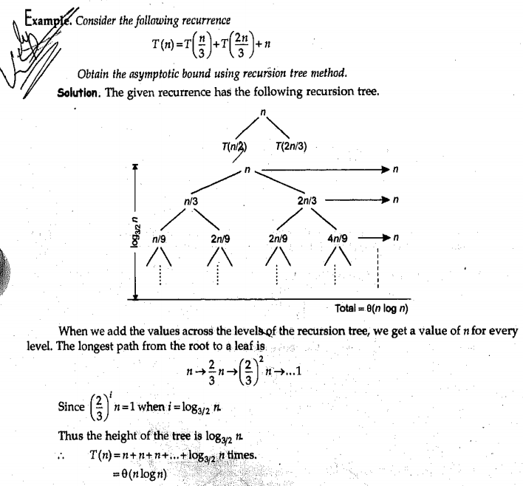
Q25.
Q26. What is Master Theorem?

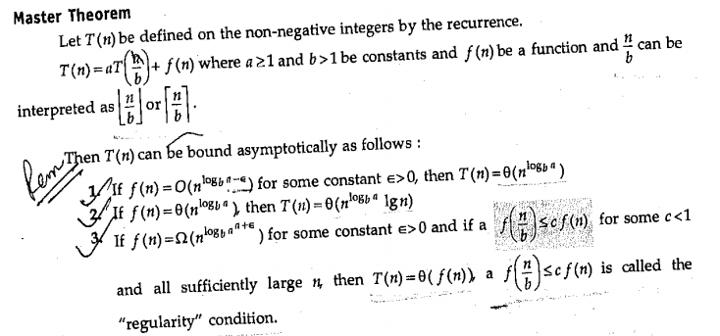
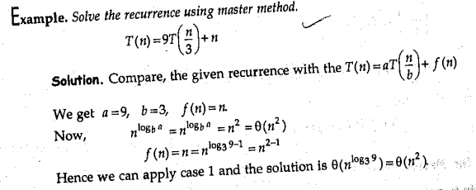
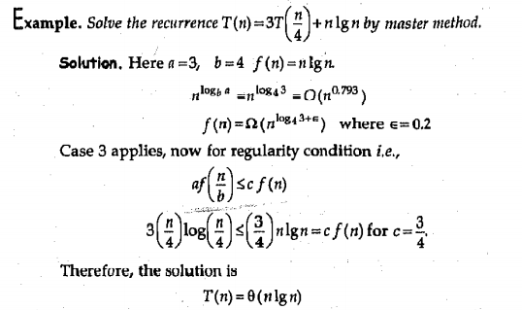

Q27. What Bubble Sort?

Bubble Sort is a simple and intuitive sorting algorithm used to arrange elements in a list or array in a specific order (usually ascending or descending). It works by repeatedly stepping through the list, comparing adjacent elements, and swapping them if they are in the wrong order. This process is repeated until the list is sorted.
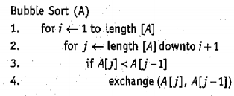

Q28 What is Selection Sort?

Selection Sort is a straightforward and intuitive comparison-based sorting algorithm. It works by repeatedly selecting the smallest (or largest, depending on the sorting order) element from the unsorted portion of the list and moving it to the beginning (or end) of the sorted portion. This process is continued until the entire list is sorted.
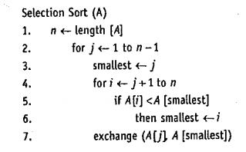

Q29. What is Insertion Sort?

Insertion Sort is a simple comparison-based sorting algorithm that builds the sorted list one element at a time. It works by taking elements from the unsorted portion of the list and inserting them into their correct position in the sorted portion.

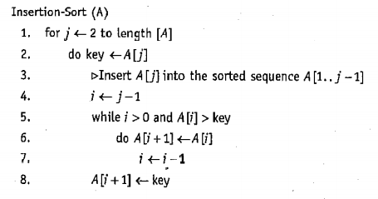

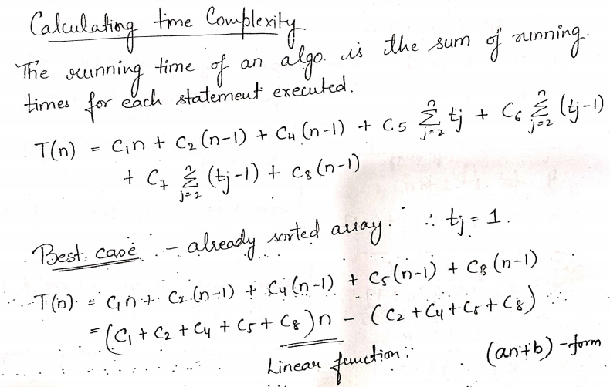
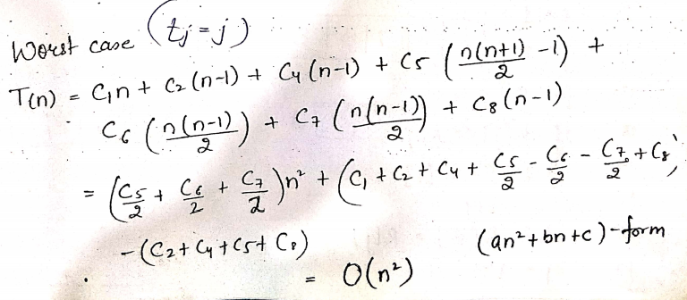

Q30. Explain Merge Sort.

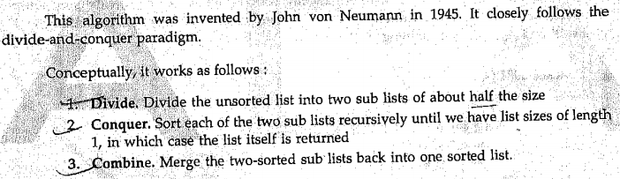

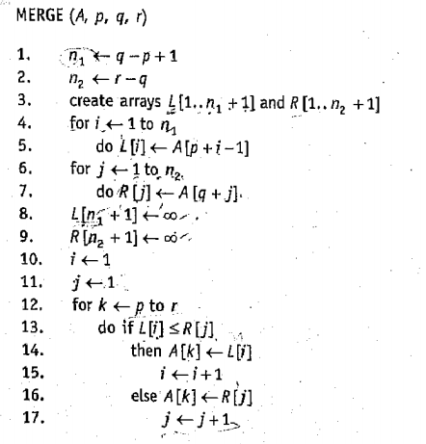

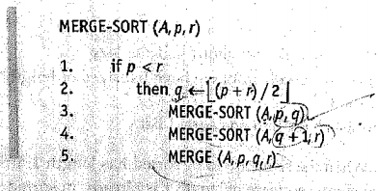

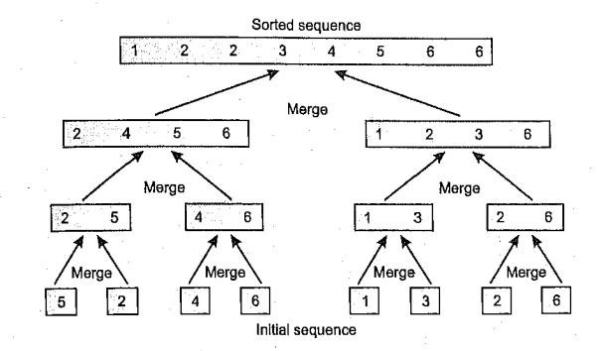

Q31. Format of Analysis of Algorithm.

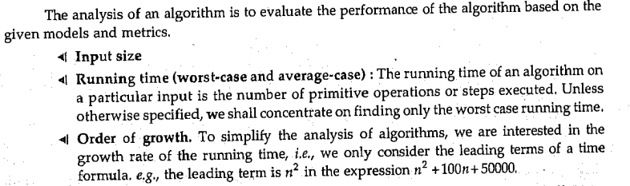

Q32. Algorithm as a technology. Comment.

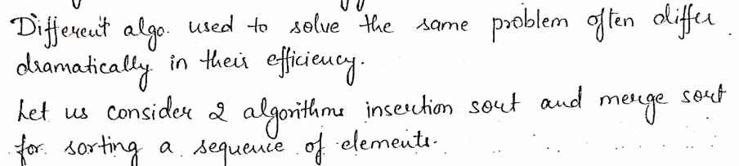
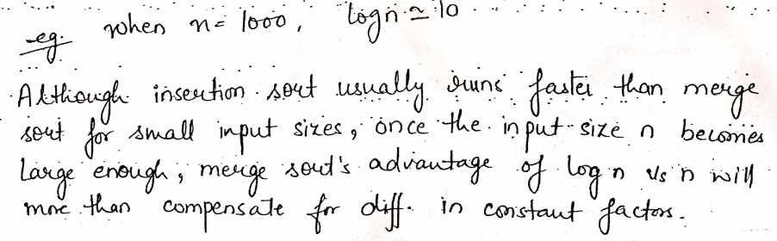
Q33 Do Analysis of Merge Sort.

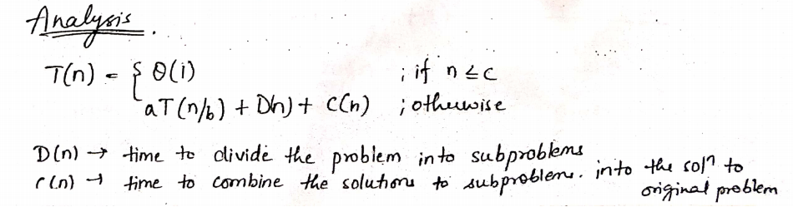

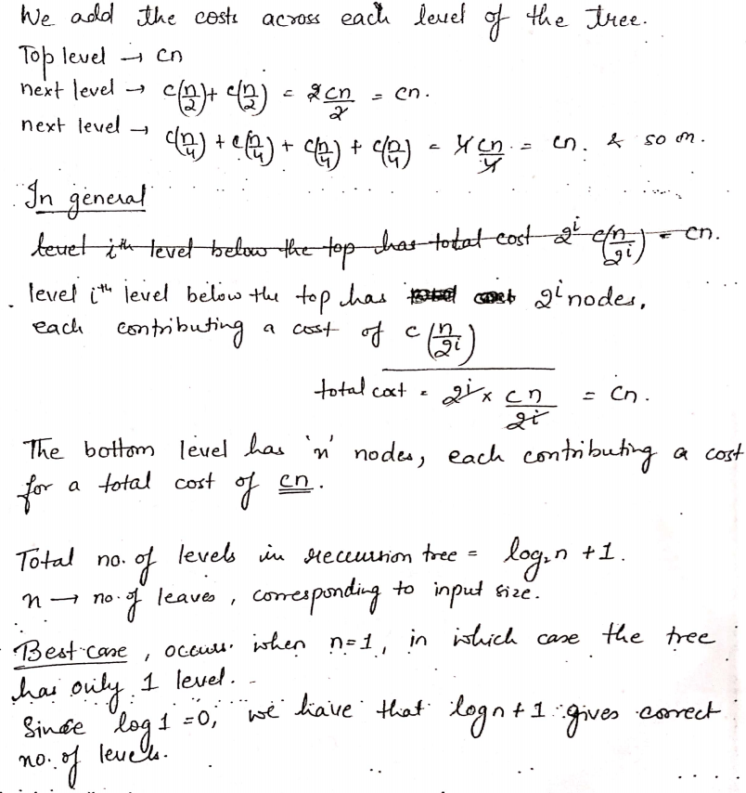

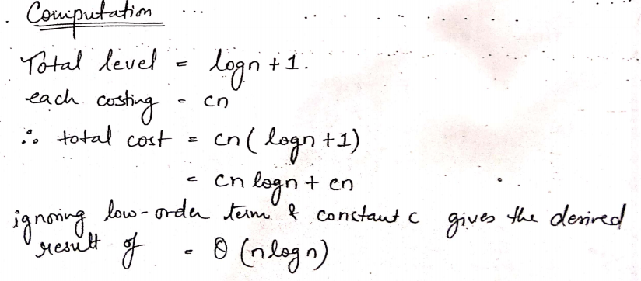

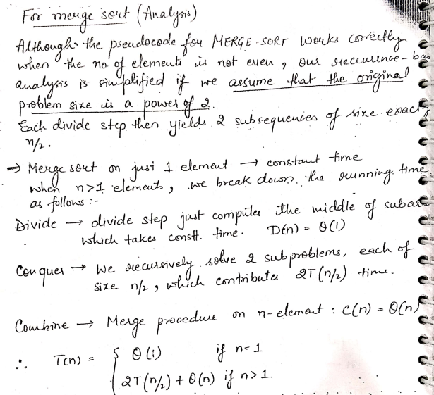

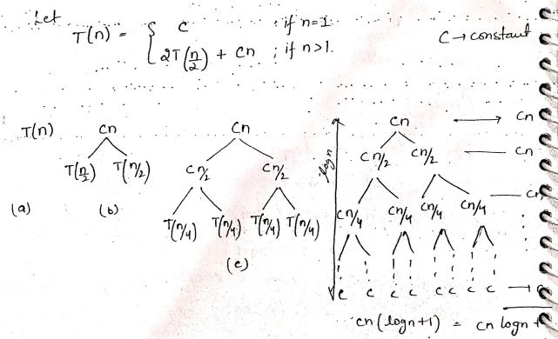

or

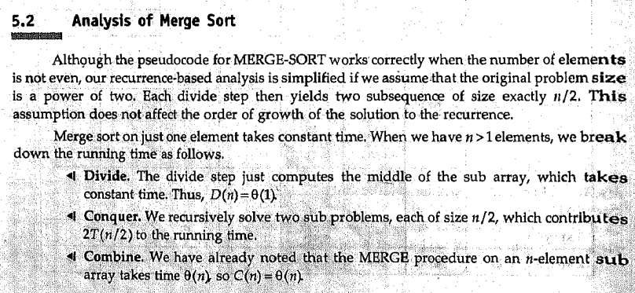
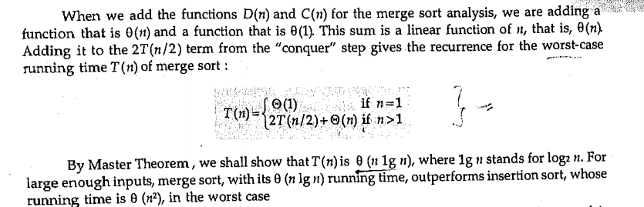
Q34. Why not use Theta all the time? Why use big Oh as default?

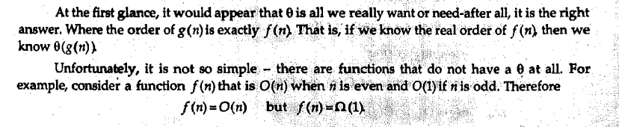
On the other hand, Big-O (O) notation is used by default because it only focuses on the upper bound, describing the worst-case scenario, which is more practical in many cases. It ensures that no matter the input, the algorithm will not perform worse than a certain limit. This makes Big-O more flexible and useful for comparing the maximum potential growth of algorithms, which is crucial in understanding performance under the worst possible conditions.

Q35. Explain Graph and all its basics.

A graph is a mathematical and data structure representation of a set of vertices (nodes) connected by edges (lines). Graphs are used to model relationships, networks, and structures in domains like social networks, transportation systems, and computer networks.
Types of Graphs:
- Undirected Graph: Edges have no direction. If there's an edge from vertex A to B, there's also an edge from B to A.
- Directed Graph (Digraph): Edges have direction. An edge from vertex A to B doesn't imply an edge from B to A.
- Weighted Graph: Assigns a weight or cost to each edge, representing some value associated with the connection between vertices.
- Cyclic Graph: Contains at least one cycle (a closed path that starts and ends at the same vertex).
- Acyclic Graph: Has no cycles. A special case is a DAG (Directed Acyclic Graph), used for topological sorting and dynamic programming.
Graph Terminology:
- Vertex (Plural: Vertices): The fundamental building blocks of a graph.
- Edge: Represents a connection between two vertices.
- Adjacent: Two vertices are adjacent if there's an edge connecting them.
- Path: A sequence of vertices where each adjacent pair is connected by an edge.
- Cycle: A path that starts and ends at the same vertex.
- Degree: The degree of a vertex is the number of edges connected to it.
- Connected Graph: In an undirected graph, there is a path between any pair of vertices.
Graph Representations:
- Adjacency Matrix: A 2D array where matrix[i][j] is 1 if there's an edge between vertex iii and jjj, and 0 otherwise. Suitable for dense graphs.
- Adjacency List: A collection of lists, one for each vertex, where each list contains the vertices adjacent to that vertex. Suitable for sparse graphs.
Graph Algorithms:
- Breadth-First Search (BFS): Explores all vertices reachable from a starting vertex in shortest-path order.
- Depth-First Search (DFS): Explores as far as possible along each branch before backtracking.
- Shortest Path Algorithms: Such as Dijkstra's and Bellman-Ford, used to find the shortest path between vertices in weighted graphs.
- Minimum Spanning Tree: Algorithms like Kruskal's and Prim's are used to find the minimum spanning tree in a weighted graph.

Q36. Explain Binary Search. Analyse Binary Search.

Binary search is an efficient algorithm used to find the position of a target value within a sorted array or list. The key advantage of binary search over linear search is its logarithmic time complexity, making it much faster for large datasets.

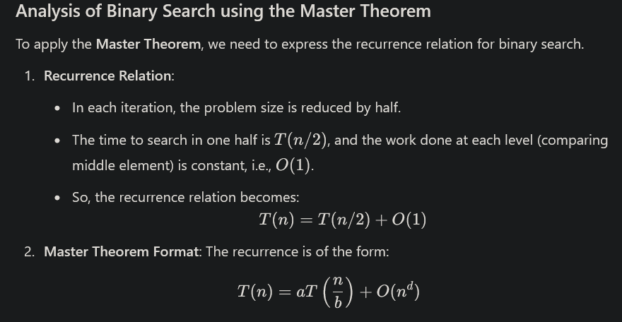
FUNCTION binary_search(arr, x):
SET low = 0
SET high = LENGTH(arr) - 1
WHILE low <= high:
SET mid = (low + high) // 2
IF arr[mid] == x THEN:
RETURN mid // Target found
ELSE IF arr[mid] < x THEN:
SET low = mid + 1 // Search in right half
ELSE:
SET high = mid - 1 // Search in left half
RETURN -1 // Target not found
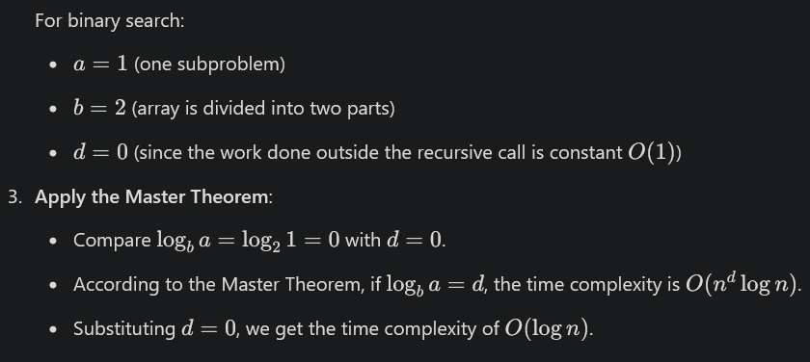

Q37. Explain Linear Search. Analyse Binary Search.

Linear search is a straightforward algorithm used to find a target value within an array or list. Unlike binary search, linear search examines each element of the array sequentially until it finds the target or reaches the end of the array.

FUNCTION linear_search(arr, x):
FOR i FROM 0 TO LENGTH(arr) - 1:
IF arr[i] == x THEN:
RETURN i // Target found
RETURN -1 // Target not found
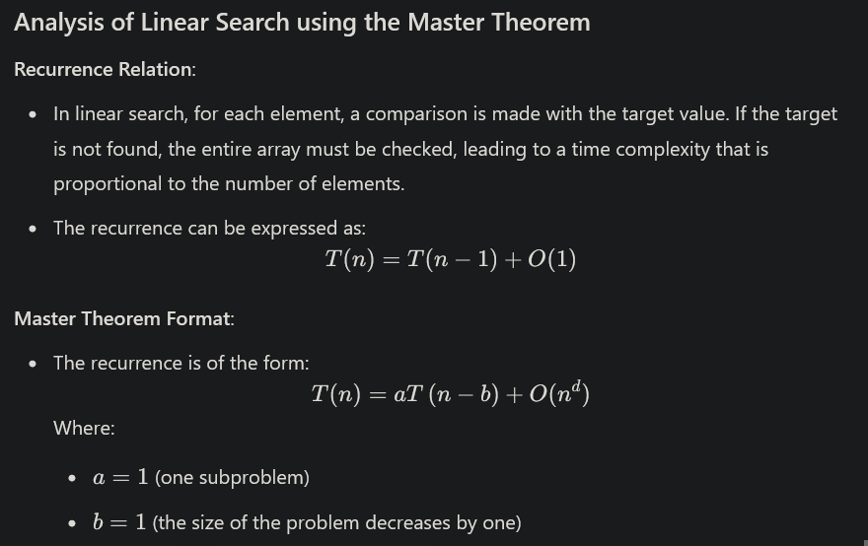

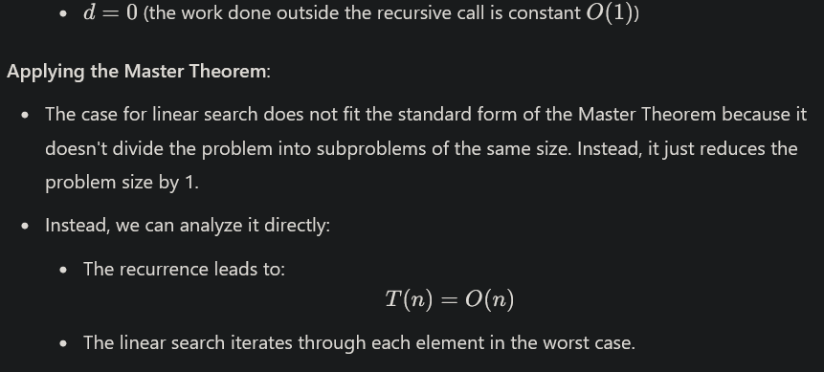

Q38. What is disjoined set? What are some operations of disjoined set? Also mention Applications of disjoined sets.

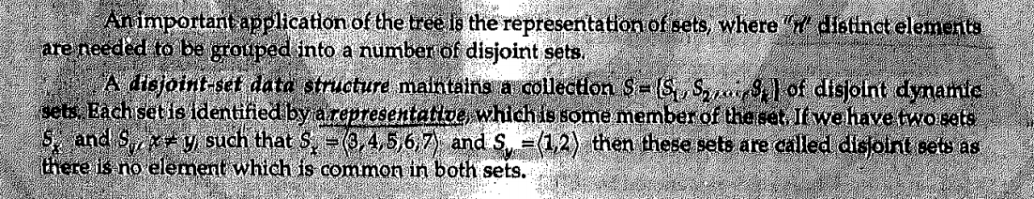
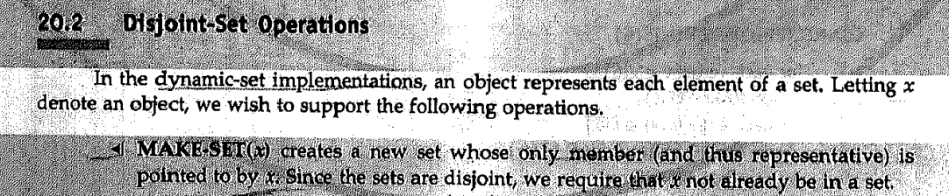
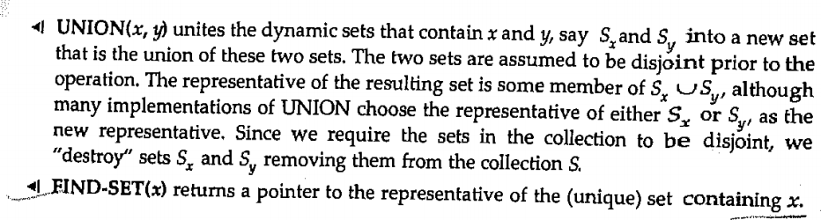

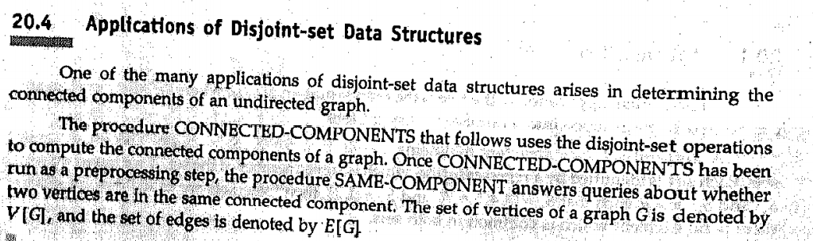

Q39. What is UNION-FIND Algorithm?

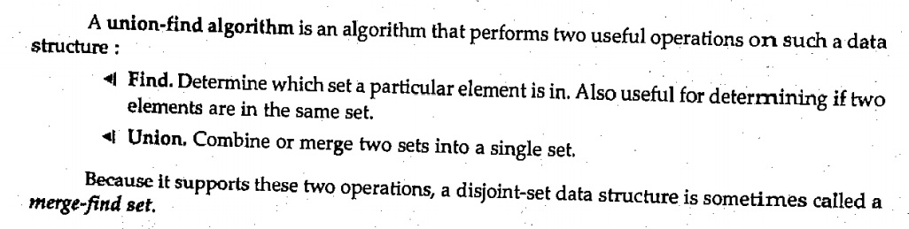
Q40. What is Disjoined Set Forest?

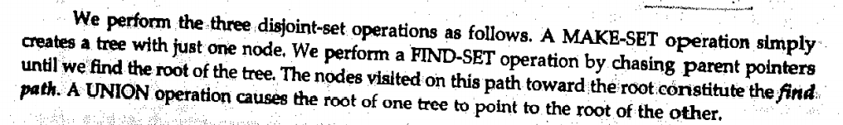
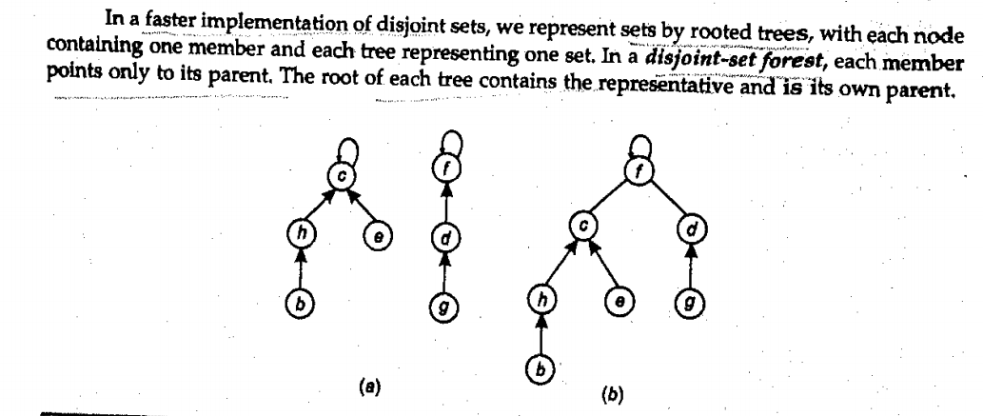

Q41. What is quick sort?
http://www.btechsmartclass.com/data_structures/quick-sort.html
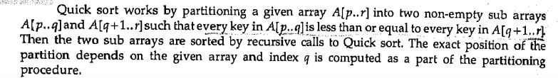
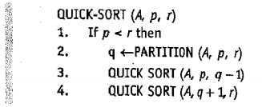

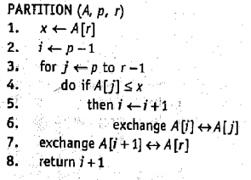

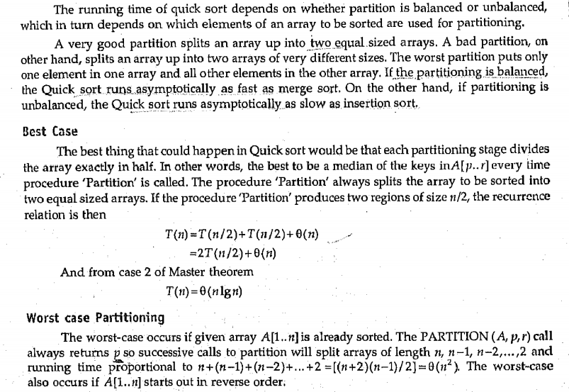
Q42. Analyse Quick Sort.

Q43. Analyse Selection Sort.
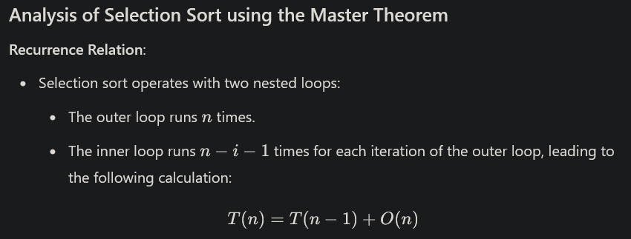
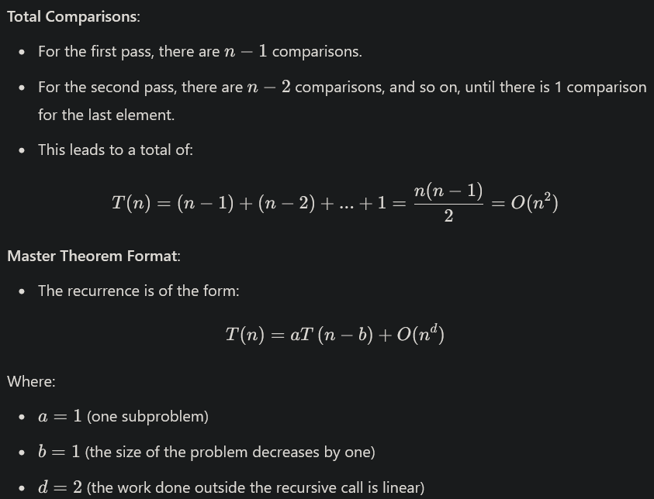
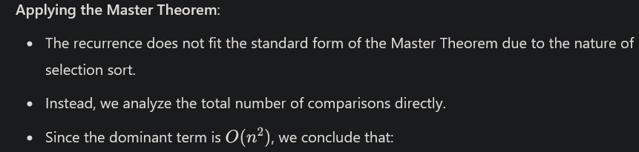

Q44. What is Strassen's Matrix?

Strassen's Matrix Multiplication Algorithm is an efficient algorithm for multiplying two matrices. It was developed by Volker Strassen in 1969 and reduces the time complexity of matrix multiplication compared to the standard algorithm. The time complexity taken by this approach is O(n3), since it takes two loops to multiply. Strassen’s method was introduced to reduce the time complexity from O(n3) to O(nlog 7).

Q45. Analysis of Strassen's Matrix?

Strassen’s method is similar to above simple divide and conquer method in the sense that this method also divide matrices to sub-matrices of size N/2 x N/2 as shown in the above diagram, but in Strassen’s method, the four sub-matrices of result are calculated using following formulae.

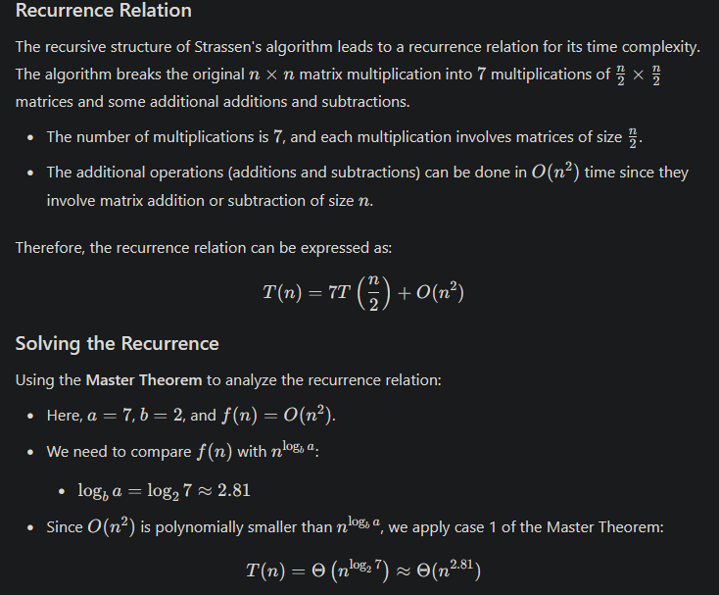

Data Structure Analysis and Algorithm

Unit – 2

Q1. Explain Greedy Algorithm.

A Greedy Algorithm is an approach used in optimization problems that builds a solution piece by piece, always choosing the next piece that offers the most immediate benefit or is the most optimal at that moment. The fundamental idea behind greedy algorithms is to make a series of choices, each of which looks best at the moment, with the hope that these local optimum choices will lead to a global optimum solution.

Example Problems Solved by Greedy Algorithms:
- Activity Selection Problem: Selecting the maximum number of activities that do not overlap in time.
- Fractional Knapsack Problem: Maximizing the total value of items in a knapsack, allowing fractional amounts of items.
- Prim's and Kruskal's Algorithms: Finding the Minimum Spanning Tree (MST) of a graph.
- Huffman Coding: Creating an optimal prefix code for data compression.

Q2. What is Activity Selector Problem?

The Activity Selection Problem is a classic optimization problem that can be efficiently solved using a greedy algorithm. The objective of the problem is to select the maximum number of activities that do not overlap in time, given a set of activities with their start and finish times.

Problem Statement
Given a set of activities, each with a start time sis_isi​ and a finish time fif_ifi​, the task is to select the maximum number of activities that can be performed by a single person, assuming that a person can only work on one activity at a time.

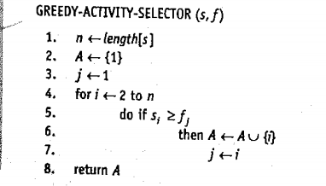

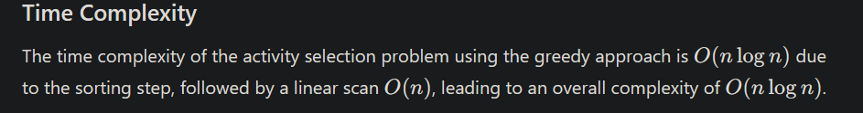
Q3 Calculate Time Complexity of Activity Selection Problem.

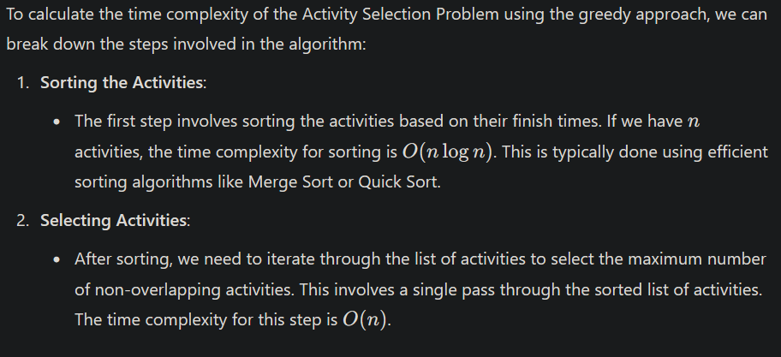
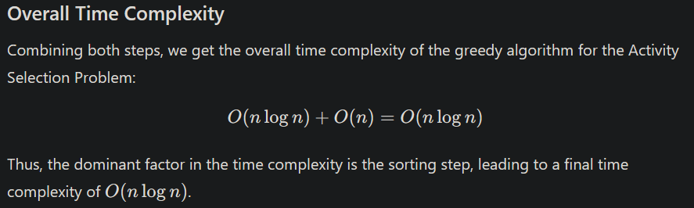

Q4.
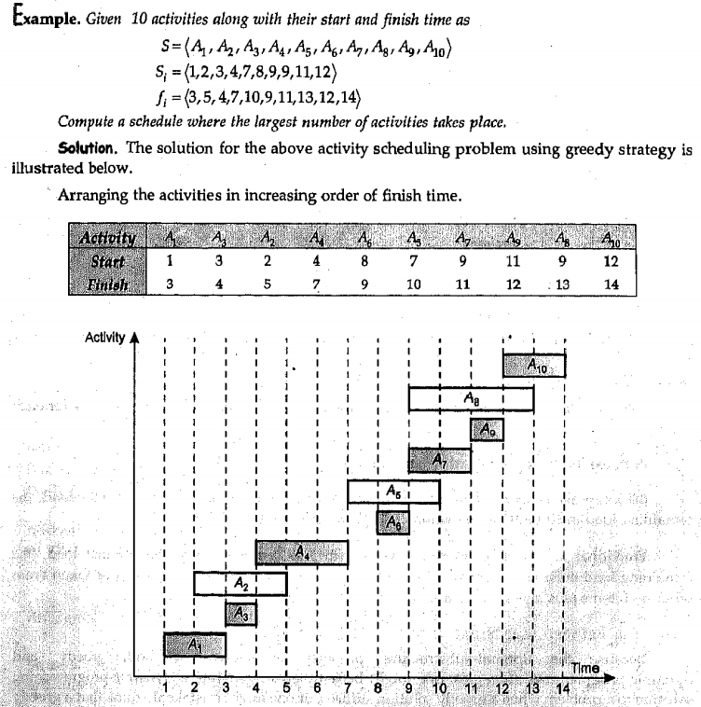
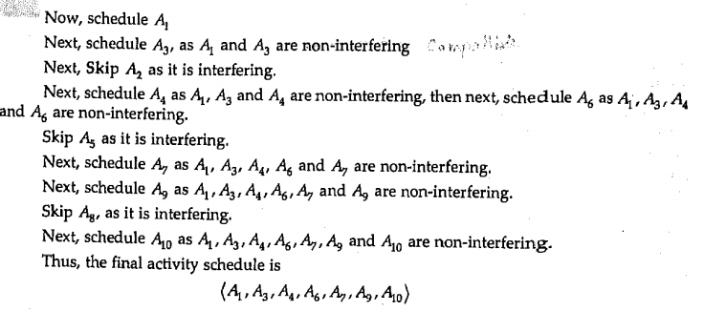
Q5. Knapsack Problems

The Knapsack Problem is a classic optimization problem that can be solved using various approaches, including dynamic programming and greedy algorithms. The problem involves selecting items with given weights and values to maximize the total value in a knapsack of limited capacity.
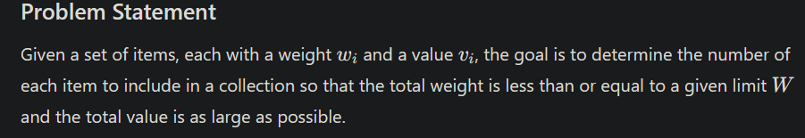
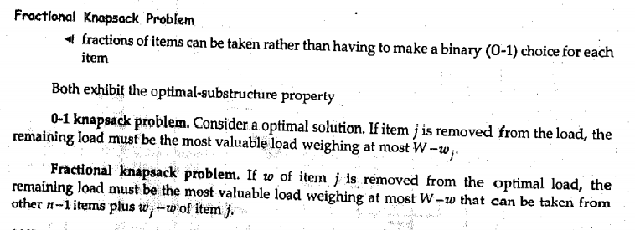
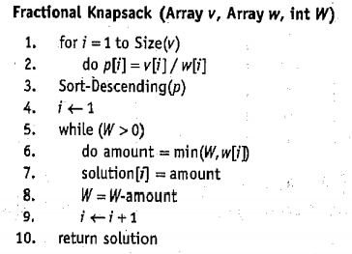

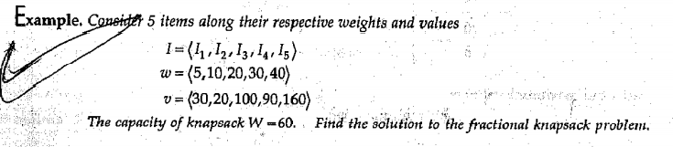
Q6.

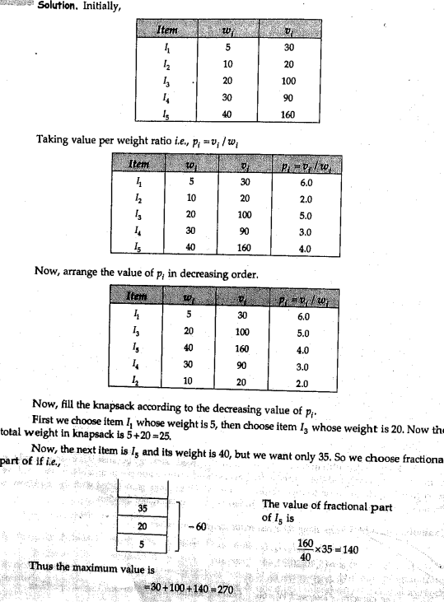

Q7. Time Complexity of fractional knapsack problem.

To calculate the time complexity of the Fractional Knapsack Problem, let's break down the steps involved in the greedy approach:
- Calculate Value-to-Weight Ratios:
  - For each item, you need to compute the value-to-weight ratio. This requires a single pass through the list of items, which takes O(n), where n is the number of items.
- Sort Items by Value-to-Weight Ratio:
  - After calculating the ratios, you need to sort the items based on their value-to-weight ratios in descending order. The time complexity for sorting is O(nlog⁡n). This is typically done using efficient sorting algorithms like Merge Sort or Quick Sort.
- Greedily Select Items:
  - Iterate through the sorted list and add items to the knapsack. For each item, if the remaining capacity allows, you take the entire item; otherwise, you take the fraction that fits. This step requires a single pass through the sorted list, which takes O(n).
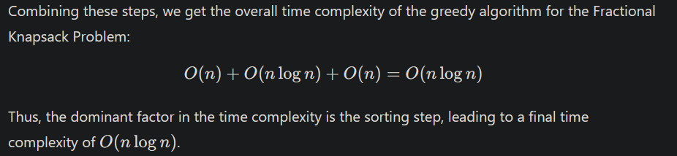
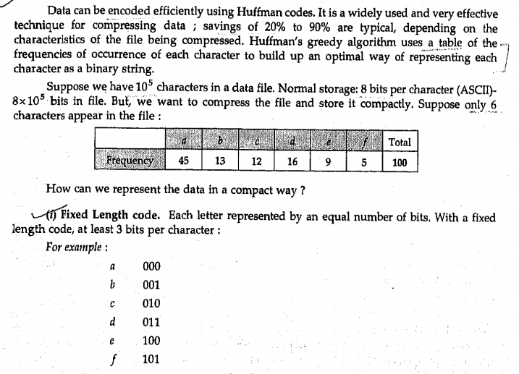
Q8. Huffman Code
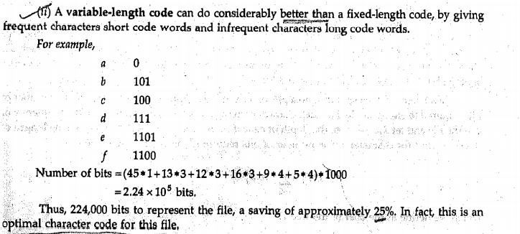
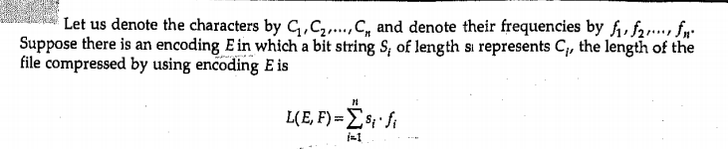
Q9. Huffman Code Analysis

Steps in Huffman Coding
- Count Frequencies: Count the frequency of each character in the input text.
- Build a Priority Queue: Insert all characters with their frequencies into a priority queue (or min-heap).
- Build the Huffman Tree: Continuously extract the two nodes with the lowest frequencies, combine them into a new node, and insert this node back into the priority queue until only one node remains (the root of the Huffman tree).
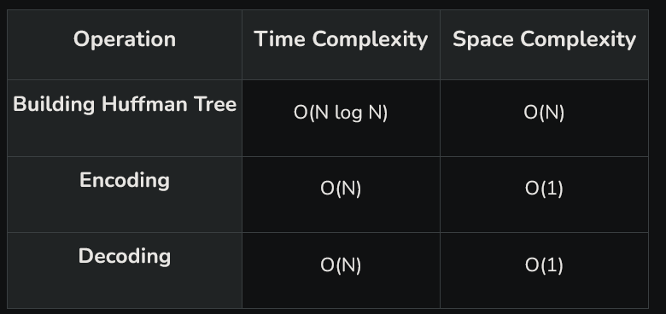
- Assign Codes: Traverse the tree to assign binary codes to each character.
Q10. Task Scheduling Problems

Task scheduling problems involve organizing and allocating tasks to resources over time, with the goal of optimizing various criteria such as completion time, resource utilization, and overall efficiency. Here’s an overview of some common task scheduling problems:

1. Definition
Task scheduling is the process of assigning tasks to resources (e.g., machines, processors, or workers) while satisfying specific constraints and optimizing an objective function. This can include minimizing completion time, maximizing resource usage, or adhering to deadlines.
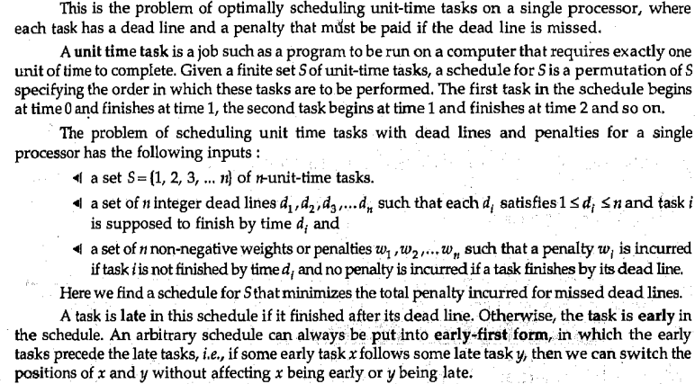
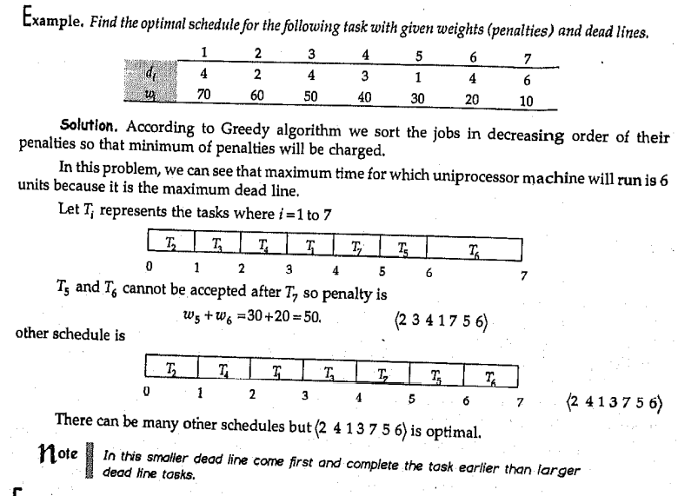
Q11. Travelling Sales man problem-solving

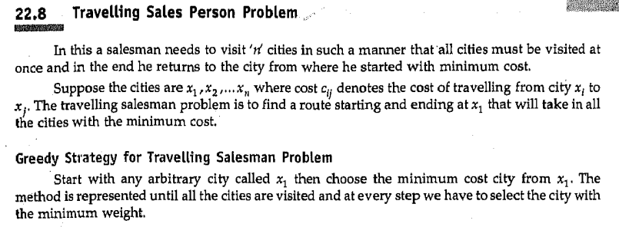
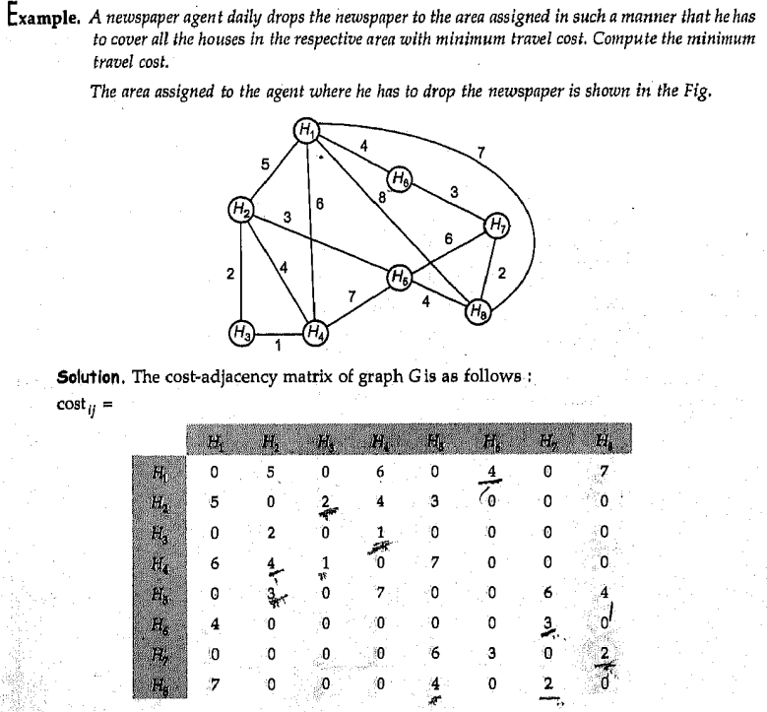
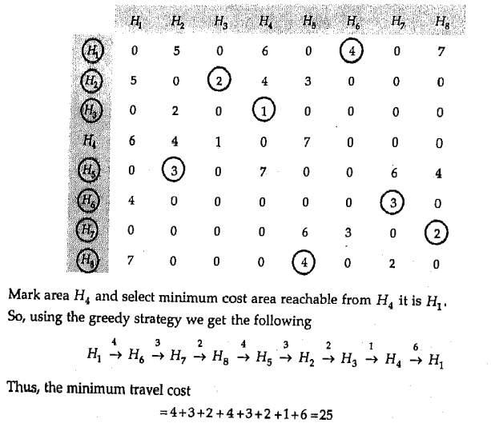

Q12. Huffman Algorithm

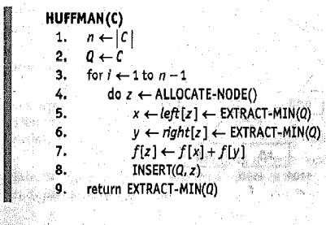

Q13. Minimum Spanning Tree

A Minimum Spanning Tree (MST) is a subset of the edges of a connected, weighted, undirected graph that connects all the vertices together without any cycles and with the minimum possible total edge weight. Here’s a detailed explanation of MSTs:

Definition
A Minimum Spanning Tree of a graph is a spanning tree with the smallest sum of edge weights. A graph may have multiple spanning trees, but only one of them will be the minimum spanning tree.
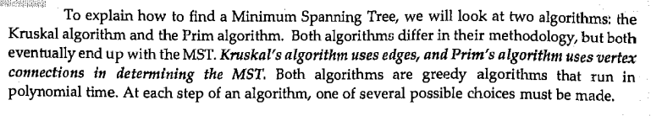
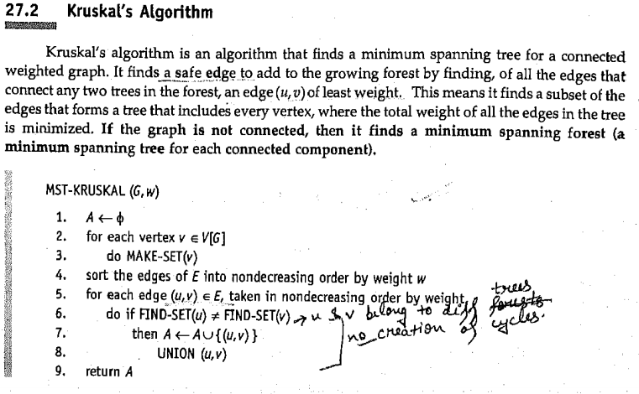
Q14. Kruskal's Algorithms

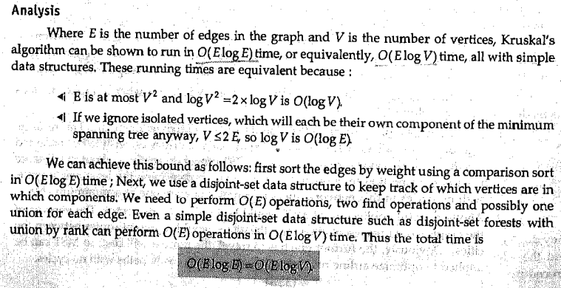

Q15.
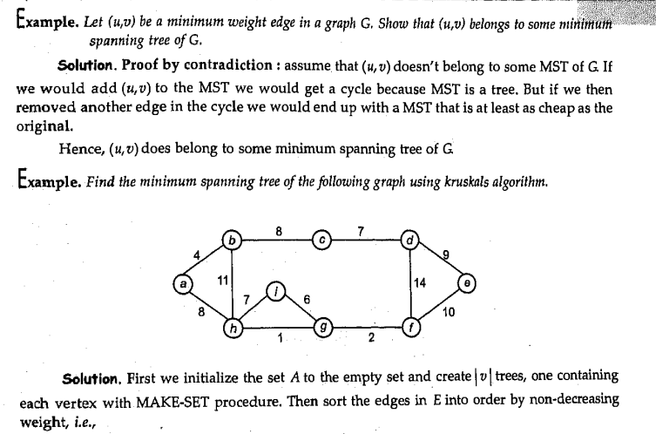
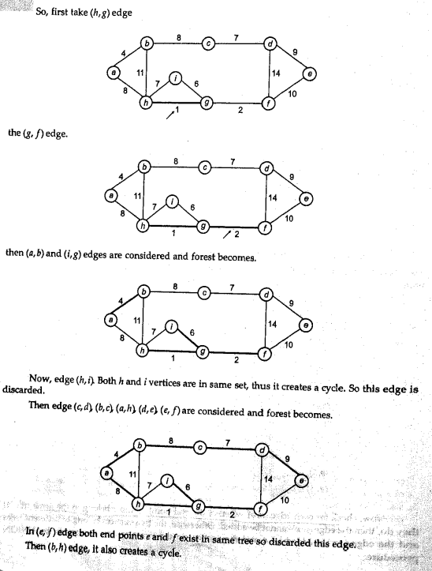

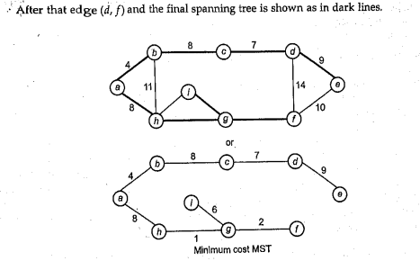

Q16. Prim’s Algorithm

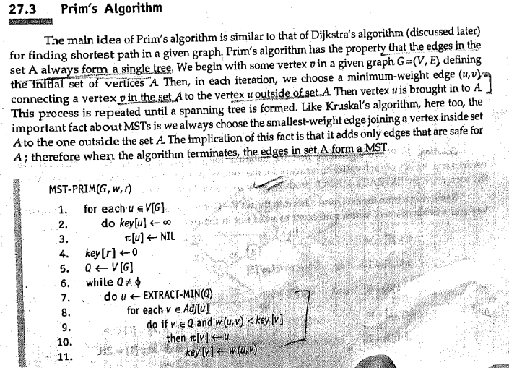

Q17. Single source shortest path

The Single Source Shortest Path (SSSP) problem involves finding the shortest paths from a given source vertex to all other vertices in a weighted graph. The graph can be either directed or undirected, and the weights of the edges can be positive or negative, depending on the algorithm used. SSSP is fundamental in many areas, such as network routing, navigation systems, and various optimization problems.

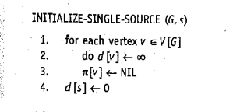

Q18. Dijkstra's Algorithm

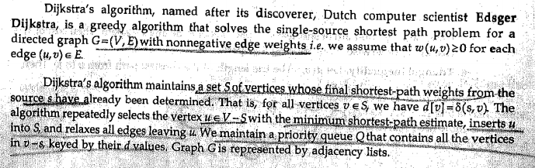

Dijkstra’s algorithm finds the shortest path from the source vertex to all other vertices in a graph with non-negative edge weights. It is a greedy algorithm that repeatedly selects the vertex with the smallest known distance to the source and updates the distances to its neighboring vertices.

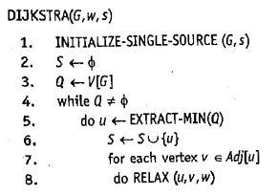

Q19. Dijkstra's Analysis

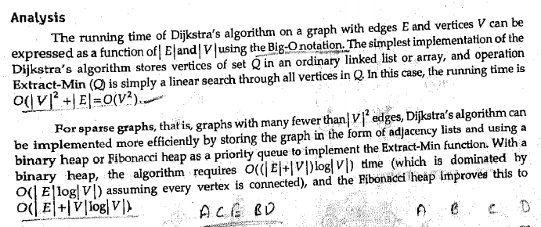
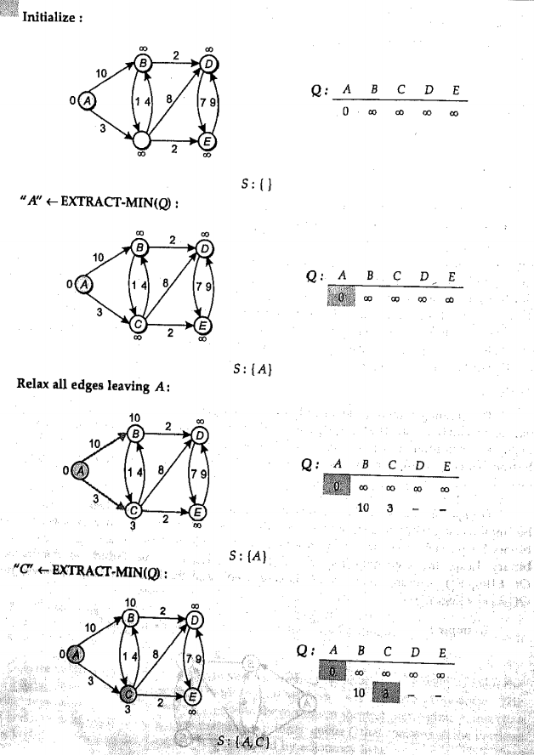
Q20.

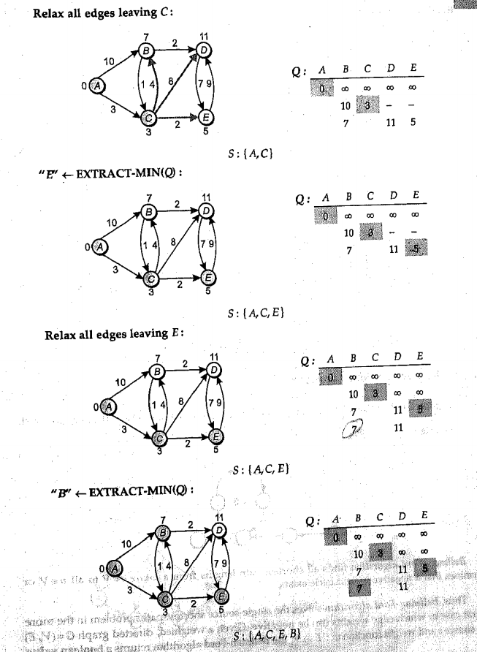

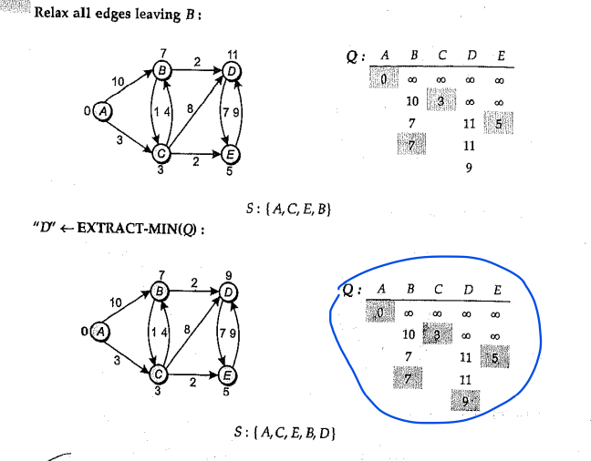

Q21. The Bellman-Ford Algorithm

The Bellman-Ford Algorithm is a single-source shortest path algorithm designed to handle graphs where edges can have negative weights. It can detect negative-weight cycles (cycles in which the total weight of the edges is negative), making it more versatile than Dijkstra's algorithm, which cannot process graphs with negative weights.

Bellman-Ford uses a dynamic programming approach and repeatedly relaxes all the edges in the graph to guarantee that the shortest path from the source vertex to any other vertex is calculated correctly.

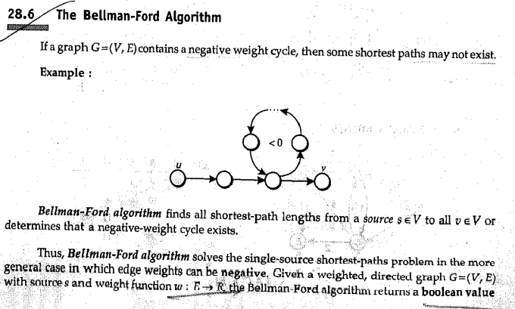
Q22. What is backtracking?

Backtracking is a problem-solving algorithmic technique used to solve complex problems by breaking them down into smaller sub-problems. It explores possible solutions incrementally, abandoning ("backtracking" from) a path as soon as it determines that the path cannot lead to a valid solution

Key Points:
- Recursive Approach: Backtracking is often implemented as a recursive algorithm.
- Trial and Error: It tries to build a solution piece by piece, checking whether the current solution satisfies the problem's conditions.
- Backtracking Step: When a partial solution is found to be invalid or no longer leads to a complete solution, the algorithm backtracks to the previous step and tries a different option.

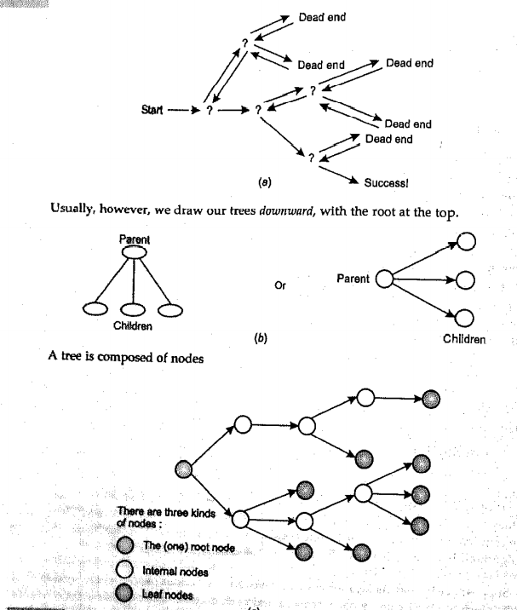

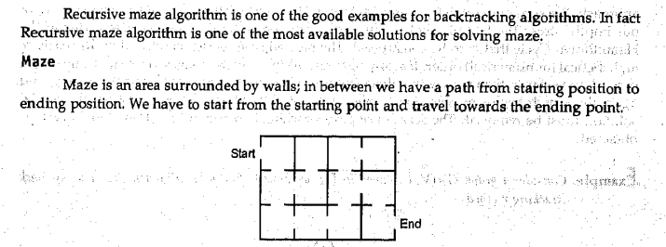
Q23. Recursive Maze Algorithms
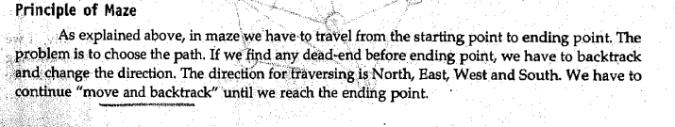
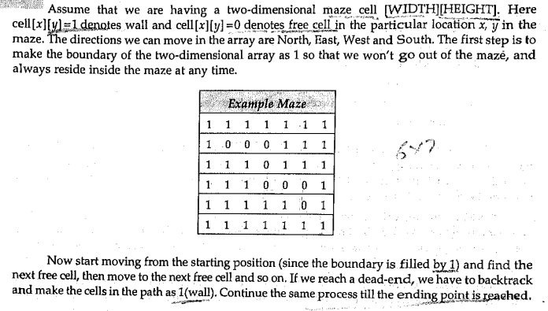
Q24. Hamiltonian Circuit Problems

A Hamiltonian Circuit (or Hamiltonian Cycle) is a problem in graph theory where the goal is to determine whether there exists a path in a graph that visits each vertex exactly once and returns to the starting vertex.

Problem Definition:
- Input: A graph G=(V,E), where V is the set of vertices and E is the set of edges.
- Output: Determine if there exists a Hamiltonian circuit, i.e., a cycle that visits every vertex exactly once and returns to the starting vertex.
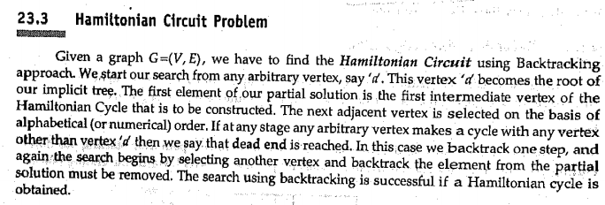
Q25.
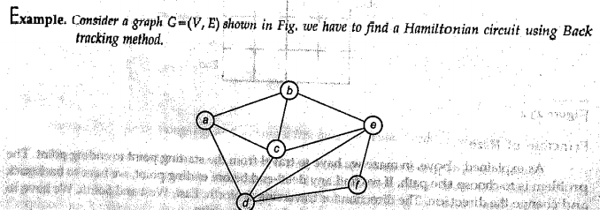

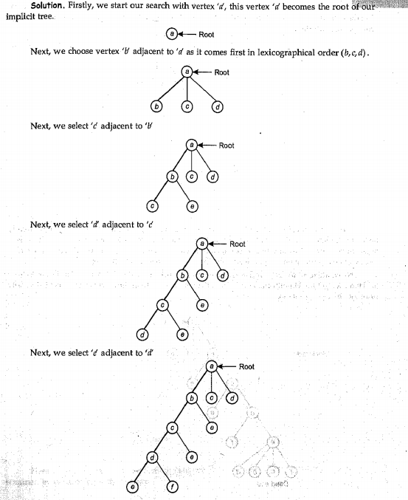
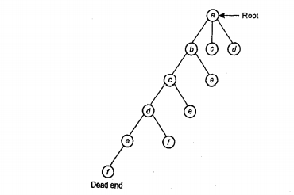
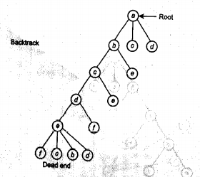

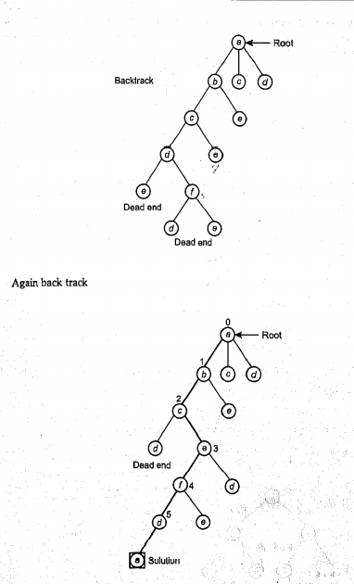

Q26. Subset-sum Problem

The Subset Sum Problem is a classic decision problem in computer science where, given a set of integers, the goal is to determine whether there is a subset of those integers that sums up to a given target value.

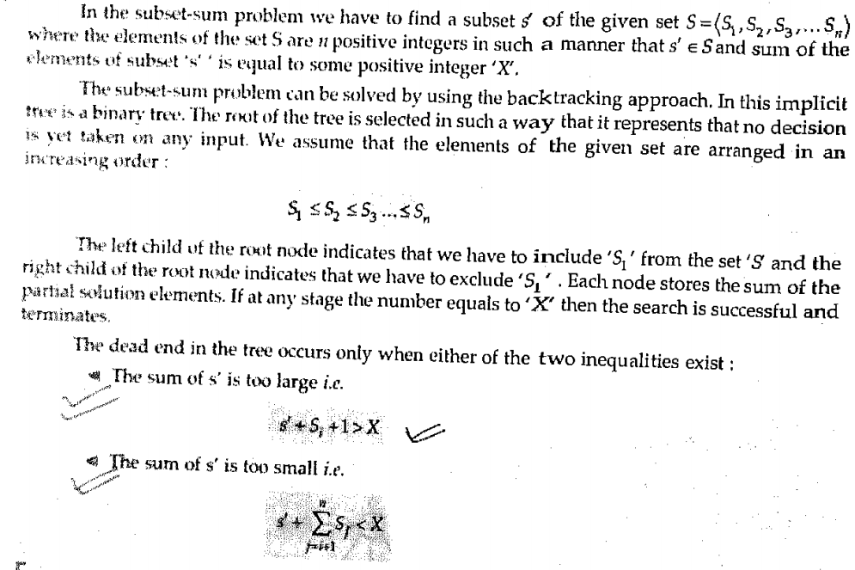
Q27.
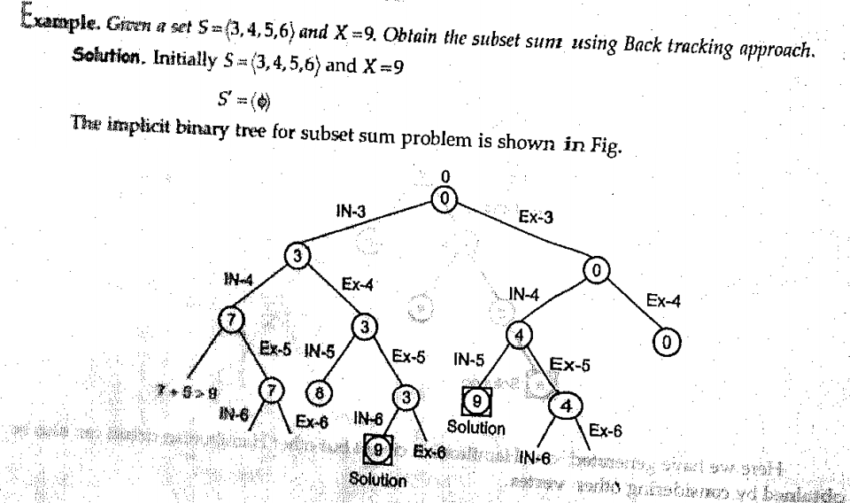
Q28. N-Queen Problems

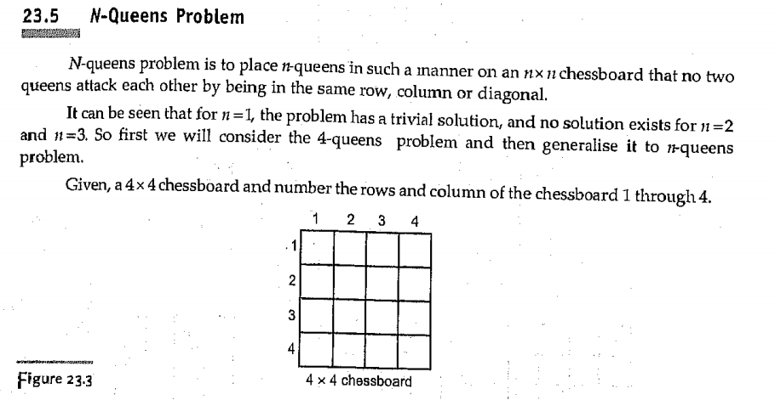

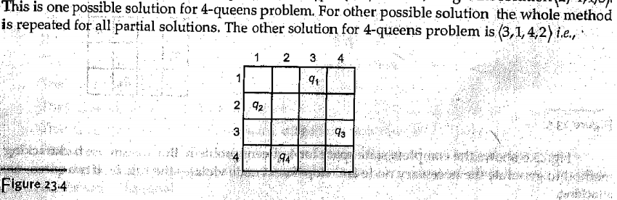

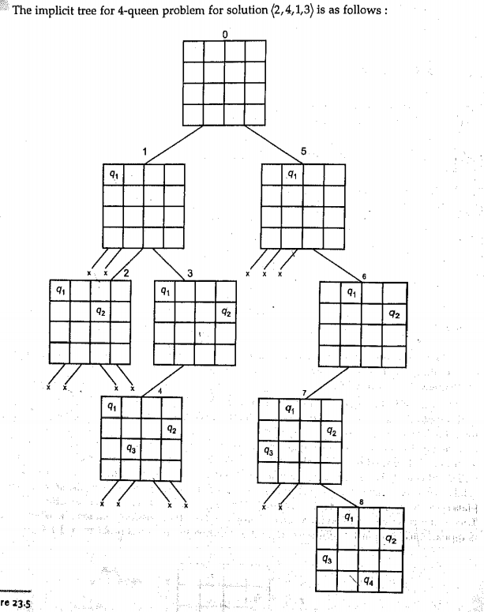

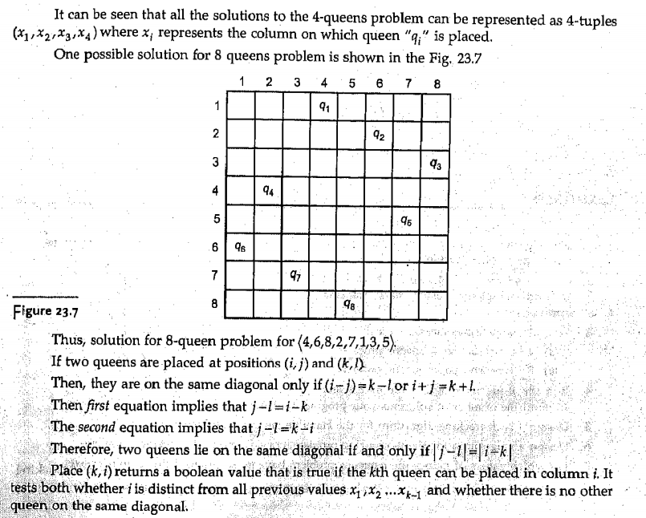
Analysis

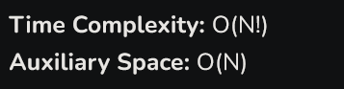

Q29. Analysis of Hamilton circuit

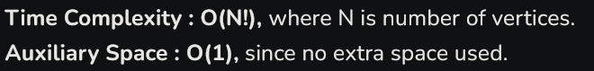

Q30. Analysis of prim’s algorithm

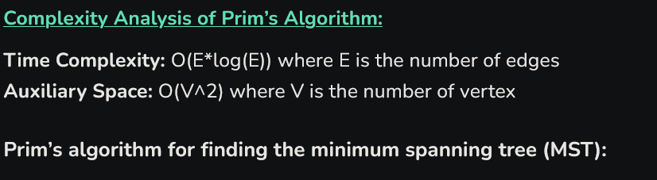

Q31. Graph Coloring Problem

Graph coloring refers to the problem of coloring vertices of a graph in such a way that no two adjacent vertices have the same color. This is also called the vertex coloring problem. If coloring is done using at most m colors, it is called m-coloring.

Chromatic Number:
The minimum number of colors needed to color a graph is called its chromatic number. For example, the following can be colored a minimum of 2 colors.
Assign colors one by one to different vertices, starting from vertex 0. Before assigning a color, check if the adjacent vertices have the same color or not. If there is any color assignment that does not violate the conditions, mark the color assignment as part of the solution. If no assignment of color is possible then backtrack and return false.
Time Complexity: O(m^n), where n is the number of vertices and m is the number of colors.

PYQ

Q1. Differentiate between Big Oh and Big Omega

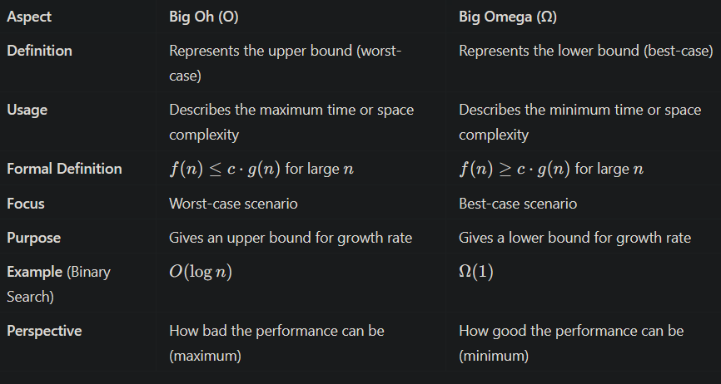

Q2. Show that backtracking is better than brute force approach in terms of time complexity.

Backtracking is generally better than the brute force approach in terms of time complexity due to the following reasons:
- Pruning the Search Space: Backtracking systematically explores potential solutions and abandons paths that are determined to be invalid early on. This reduces the number of configurations that need to be examined compared to brute force, which evaluates every possible solution.
- Efficiency in Finding Solutions: Backtracking narrows down the search by only considering feasible solutions, leading to a quicker resolution for many problems. Brute force, on the other hand, often involves checking all combinations, making it less efficient.
- Reduced Time Complexity: While both approaches may exhibit exponential time complexity in the worst case, backtracking typically has a lower average-case time complexity due to its ability to skip invalid paths. This means that, in practical scenarios, backtracking usually performs better than brute force.
- Scalability: Backtracking algorithms can handle larger inputs more effectively because they do not exhaustively search all possibilities, allowing them to scale better with increased problem size.

Q3. Define greedy approach. For what find of problems it can be applied? What are its advantage and disadvantage.

he greedy approach is an algorithmic strategy that makes a series of choices, each of which looks best at the moment, with the hope of finding a global optimum. Rather than considering all possible solutions, it makes the locally optimal choice at each step with the intention that these local solutions will lead to a globally optimal solution.

Problems Suitable for the Greedy Approach
The greedy approach can be effectively applied to problems where:
- Optimal Substructure: The optimal solution to the problem can be constructed from optimal solutions of its subproblems. This means that the problem can be broken down into smaller, manageable subproblems that are solved independently.
- Greedy Choice Property: A globally optimal solution can be reached by selecting the local optimal choices. In other words, a local optimal choice will lead to a global optimal solution.
Common problems that can be solved using the greedy approach include:
- Activity Selection Problem
- Fractional Knapsack Problem
- Prim's and Kruskal's algorithms for Minimum Spanning Tree
- Dijkstra's Algorithm for Shortest Path
- Huffman Coding for data compression

Advantages of the Greedy Approach
- Simplicity: Greedy algorithms are often easier to understand and implement compared to other approaches like dynamic programming.
- Efficiency: They typically have lower time complexity, as they make decisions without exploring all possible configurations, leading to faster execution.
- Space Efficiency: Greedy algorithms usually require less memory, as they do not store multiple solutions or states.

Disadvantages of the Greedy Approach
- Not Always Optimal: The greedy approach does not guarantee a globally optimal solution for all problems. It can fail to find the best solution in cases where local optimal choices lead to suboptimal results overall.
- Requires Specific Problem Characteristics: The greedy method is applicable only to specific problems that exhibit the optimal substructure and greedy choice property, limiting its usability.

Q4. The frequency of character A=5, B=45,C=30, D=15, E=3,F=2. Generate an efficient coding using huffman encoding. also calculate the numbers of bits saved for a 100 character text in comparison to fix length encoding

To generate efficient coding using Huffman encoding for the given character frequencies, we follow these steps:

Step 1: Create a Huffman Tree
- Character Frequencies:
  - A: 5
  - B: 45
  - C: 30
  - D: 15
  - E: 3
  - F: 2
- Build the Tree:
  - Create leaf nodes for each character and insert them into a priority queue based on their frequencies.
  - Extract the two nodes with the lowest frequencies, combine them into a new node with a frequency equal to the sum of the two, and insert it back into the queue.
  - Repeat this process until only one node remains, which becomes the root of the Huffman tree.

Step 2: Generate Huffman Codes
By traversing the Huffman tree, we can assign binary codes to each character:
- Assign '0' for the left branch and '1' for the right branch.

Step 3: Huffman Encoding
Following the Huffman tree construction, we get the following codes:
- A: 001
- B: 0
- C: 10
- D: 011
- E: 0001
- F: 0000

Step 4: Calculate Bits Saved Compared to Fixed-Length Encoding
- Fixed-Length Encoding:
  - Since there are 6 characters (A, B, C, D, E, F), we need ⌈log⁡2(6)⌉=3\lceil \log_2(6) \rceil = 3⌈log2​(6)⌉=3 bits per character.
  - For a 100-character text: 100×3=300 bits100 \times 3 = 300 \text{ bits}100×3=300 bits
- Huffman Encoding Calculation:
  - Calculate the total number of bits used for Huffman encoding based on character frequencies and their corresponding codes:
  - Total bits:
    - A: 5×3=155 \times 3 = 155×3=15
    - B: 45×1=4545 \times 1 = 4545×1=45
    - C: 30×2=6030 \times 2 = 6030×2=60
    - D: 15×3=4515 \times 3 = 4515×3=45
    - E: 3×4=123 \times 4 = 123×4=12
    - F: 2×4=82 \times 4 = 82×4=8
  - Total bits used in Huffman Encoding:
15+45+60+45+12+8=185 bits15 + 45 + 60 + 45 + 12 + 8 = 185 \text{ bits}15+45+60+45+12+8=185 bits
- Bits Saved:
  - Calculate the number of bits saved:
300−185=115 bits saved300 - 185 = 115 \text{ bits saved}300−185=115 bits saved

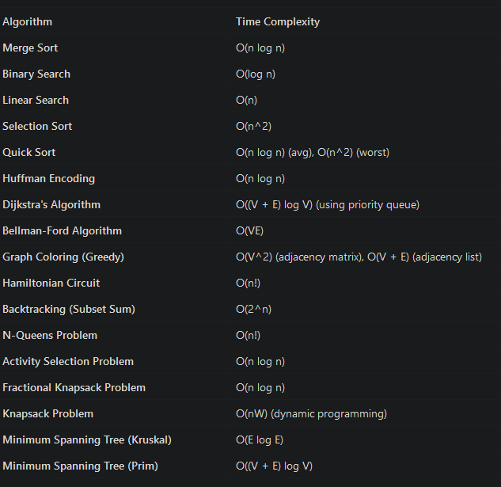

Unit – 3

Q1. What is dynamic programming?

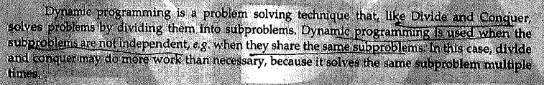
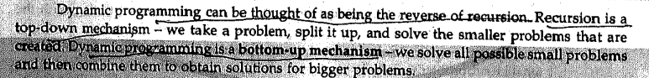
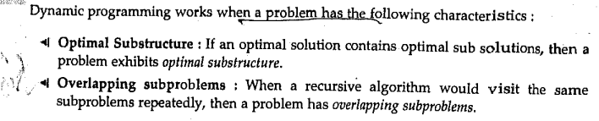

Q2. Why do we need overlapping sub-problems in Dynamic programming?

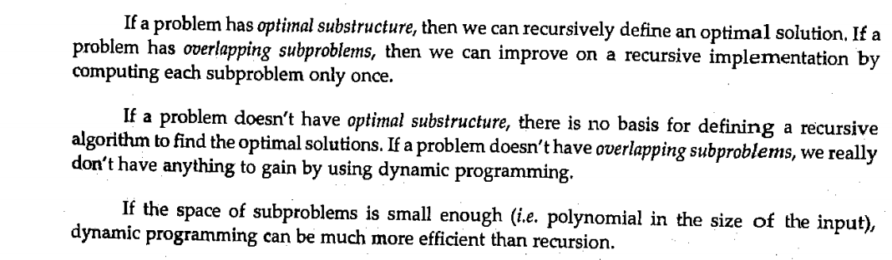
Q3. How Dynamic Program Algorithm can be Developed?

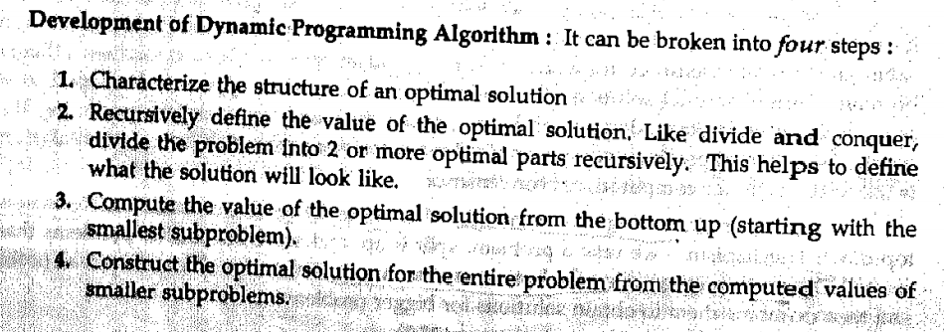
Q4. What are the characteristics of DP (Dynamic Programming) Problems?

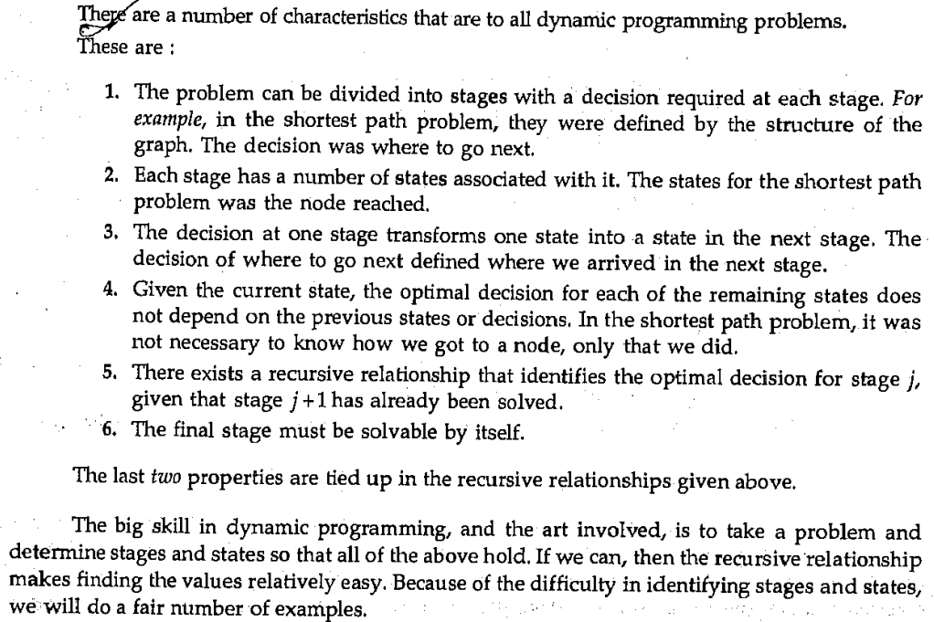
Q5. Explain the number of ways for parenthesizing a matrices?

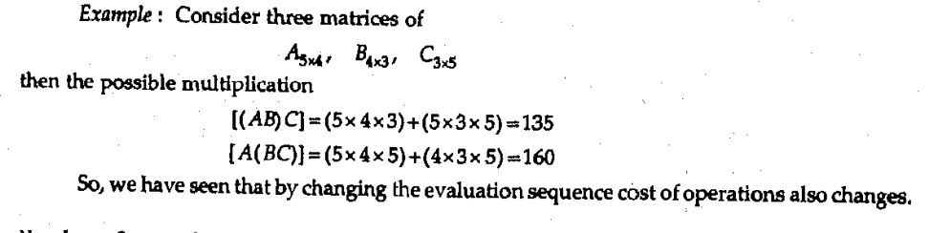
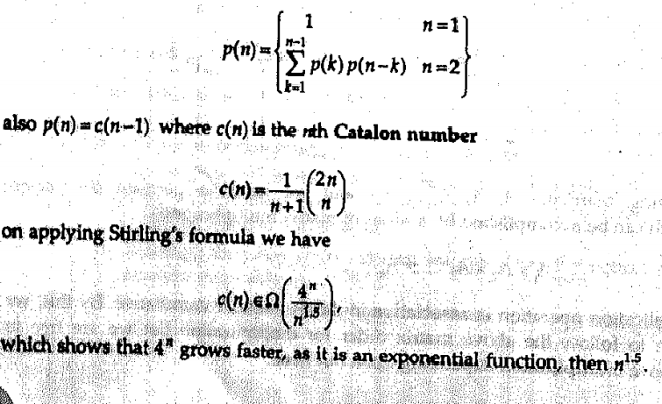
Q6. Explain Matrix Chain Multiplication.

Matrix Chain Multiplication is an algorithm that is applied to determine the lowest cost way for multiplying matrices. The actual multiplication is done using the standard way of multiplying the matrices, i.e., it follows the basic rule that the number of rows in one matrix must be equal to the number of columns in another matrix. Hence, multiple scalar multiplications must be done to achieve the product.

Matrix Chain Multiplication Algorithm
Matrix chain multiplication algorithm is only applied to find the minimum cost way to multiply a sequence of matrices. Therefore, the input taken by the algorithm is the sequence of matrices while the output achieved is the lowest cost parenthesization.

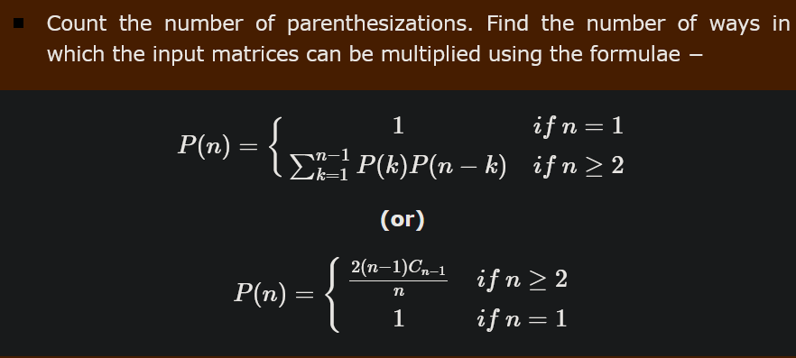
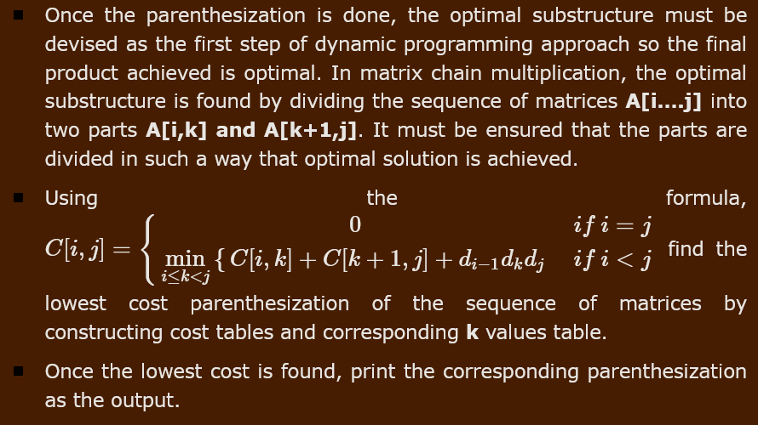

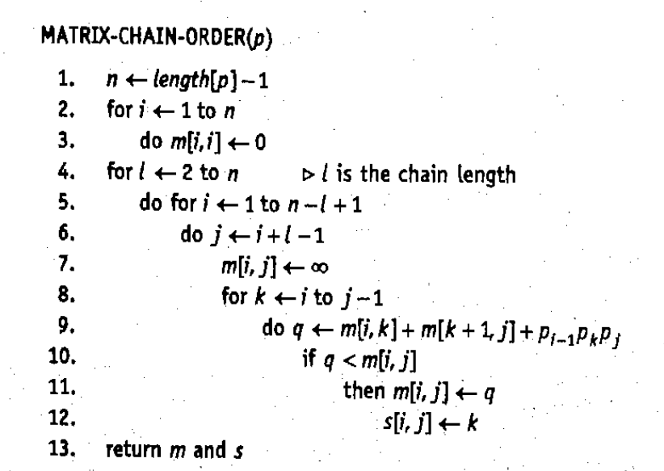

Q7.

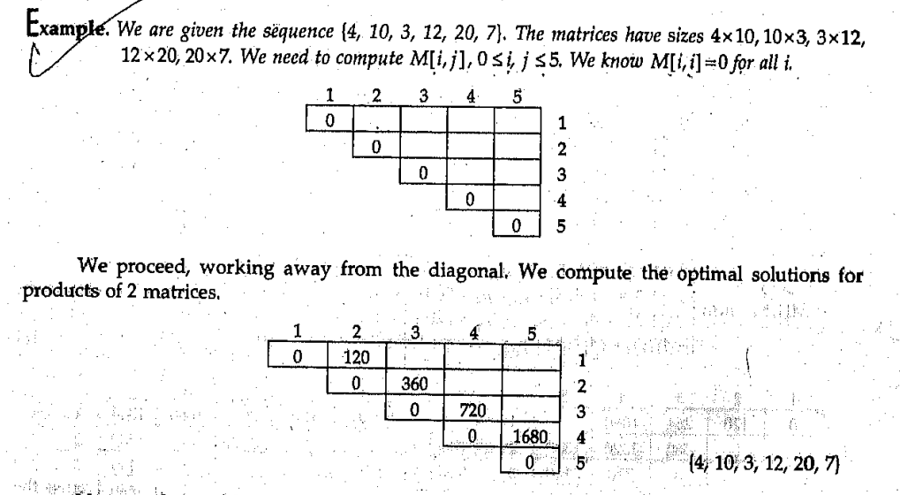
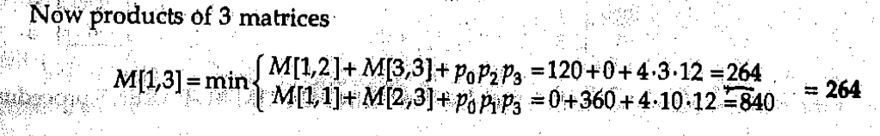

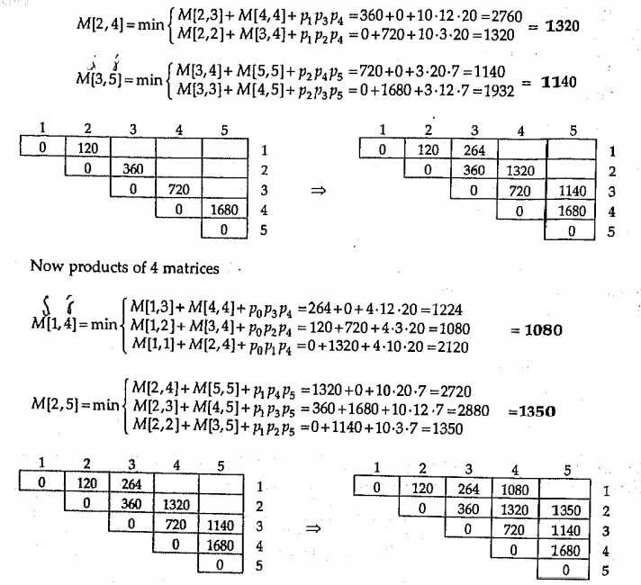
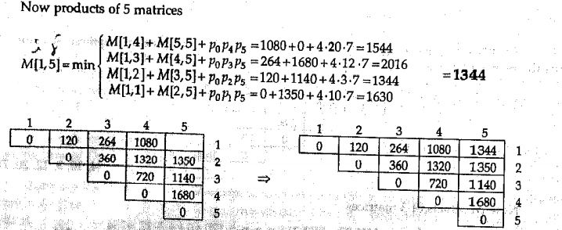

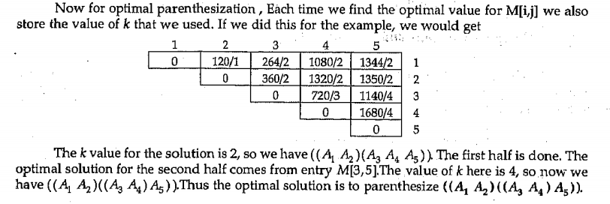
Q8. What is Memorized Matrix Chain Multiplication?

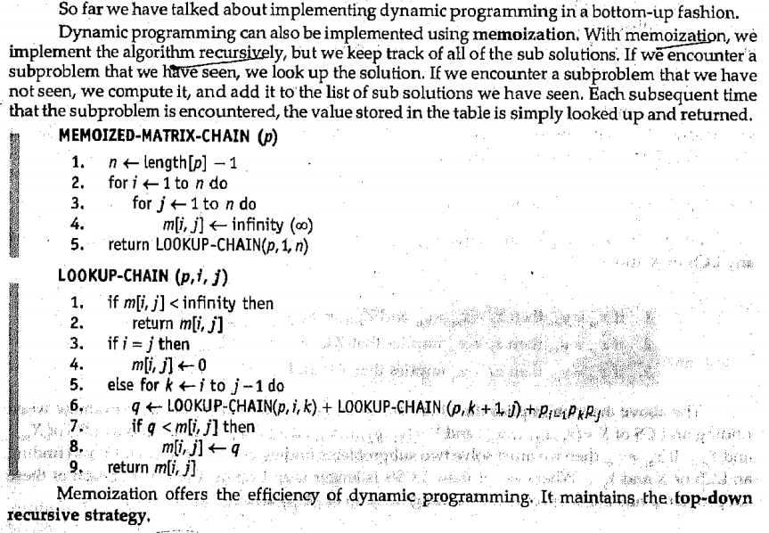
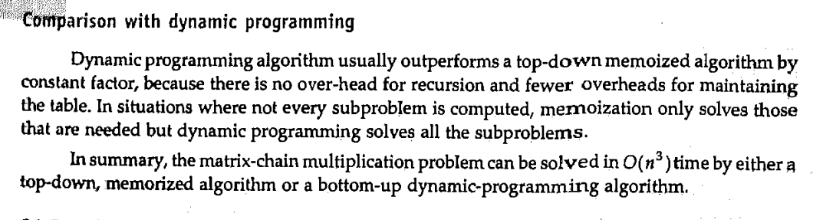
Q9. What is Longest Common Subsequence Problem?

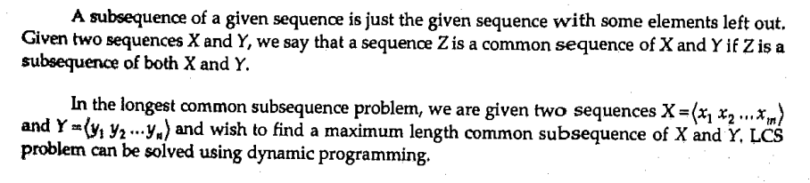

Common Subsequence
Suppose, X and Y are two sequences over a finite set of elements. We can say that Z is a common subsequence of X and Y, if Z is a subsequence of both X and Y

Longest Common Subsequence
If a set of sequences are given, the longest common subsequence problem is to find a common subsequence of all the sequences that is of maximal length.

Naive Method
Let X be a sequence of length m and Y a sequence of length n. Check for every subsequence of X whether it is a subsequence of Y, and return the longest common subsequence found.There are 2m subsequences of X. Testing sequences whether or not it is a subsequence of Y takes O(n) time. Thus, the naive algorithm would take O(n2m) time.
Q10. Explain Algorithm of LCS?

Longest Common Subsequence Algorithm
Let X=<x1,x2,x3....,xm> and Y=<y1,y2,y3....,ym> be the sequences. To compute the length of an element the following algorithm is used.
Step 1 − Construct an empty adjacency table with the size, n × m, where n = size of sequence X and m = size of sequence Y. The rows in the table represent the elements in sequence X and columns represent the elements in sequence Y.
Step 2 − The zeroeth rows and columns must be filled with zeroes. And the remaining values are filled in based on different cases, by maintaining a counter value.
- Case 1 − If the counter encounters common element in both X and Y sequences, increment the counter by 1.
- Case 2 − If the counter does not encounter common elements in X and Y sequences at T[i, j], find the maximum value between T[i-1, j] and T[i, j-1] to fill it in T[i, j].
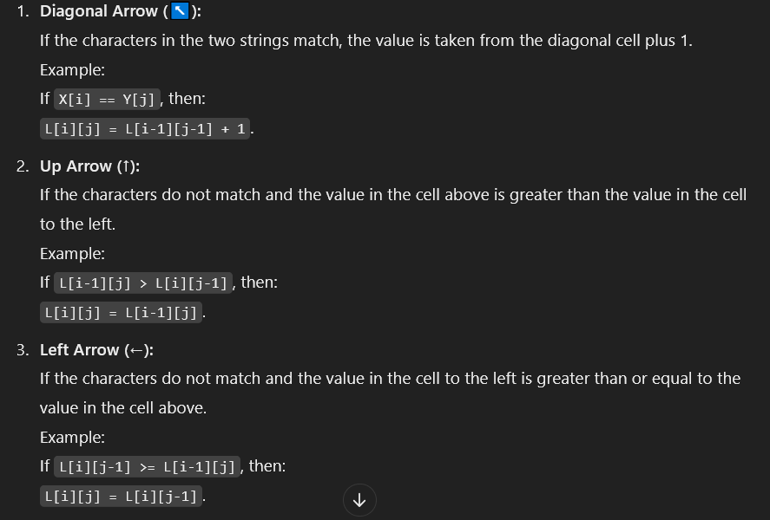

Step 3 − Once the table is filled, backtrack from the last value in the table. Backtracking here is done by tracing the path where the counter incremented first.
Step 4 − The longest common subseqence obtained by noting the elements in the traced path.
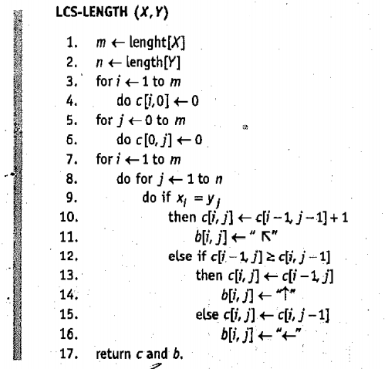

Analysis
To populate the table, the outer for loop iterates m times and the inner for loop iterates n times. Hence, the complexity of the algorithm is O(m,n), where m and n are the length of two strings.

Q11.

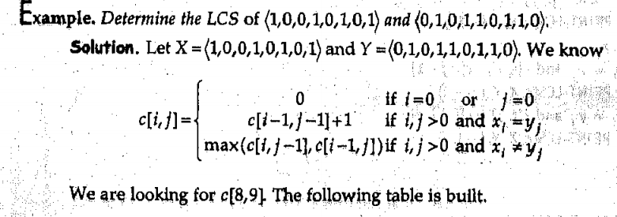
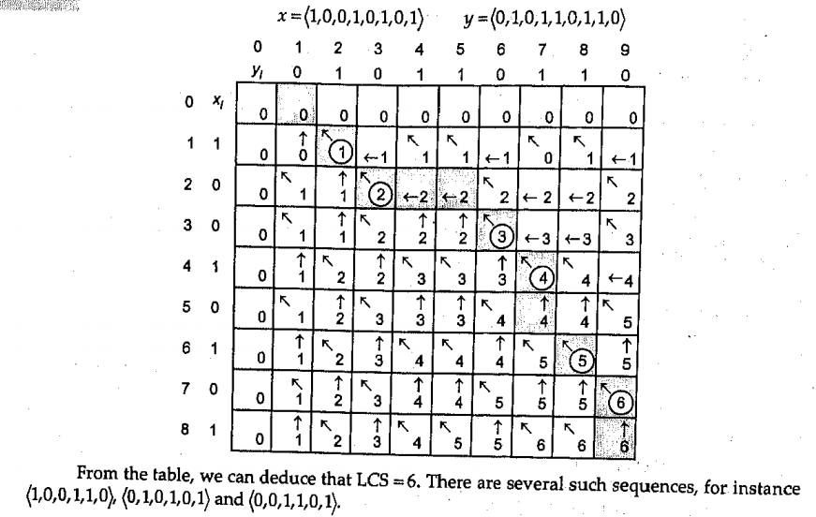
Q12.

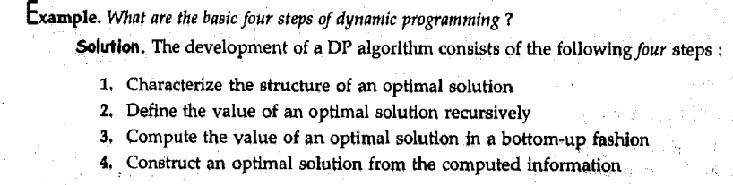

Q13. What is Optimal Binary Search?

As we know that in binary search tree, the nodes in the left subtree have lesser value than the root node and the nodes in the right subtree have greater value than the root node.
We know the key values of each node in the tree, and we also know the frequencies of each node in terms of searching means how much time is required to search a node.
The frequency and key-value determine the overall cost of searching a node. The cost of searching is a very important factor in various applications. The overall cost of searching a node should be less.

The time required to search a node in BST is more than the balanced binary search tree as a balanced binary search tree contains a lesser number of levels than the BST. There is one way that can reduce the cost of a binary search tree is known as an optimal binary search tree.

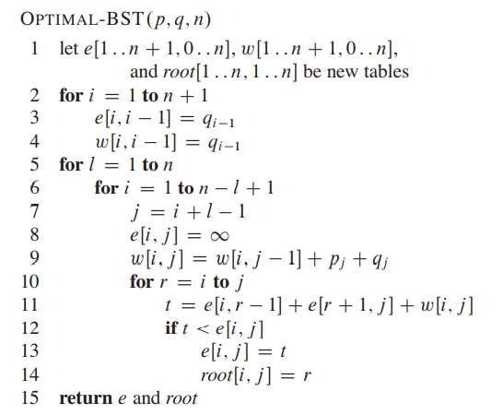

Let's understand through an example.
If the keys are 10, 20, 30, 40, 50, 60, 70

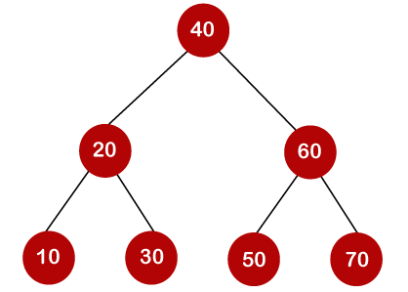

In the above tree, all the nodes on the left subtree are smaller than the value of the root node, and all the nodes on the right subtree are larger than the value of the root node. The maximum time required to search a node is equal to the minimum height of the tree, equal to logn.
Now we will see how many binary search trees can be made from the given number of keys.
For example: 10, 20, 30 are the keys, and the following are the binary search trees that can be made out from these keys.
The Formula for calculating the number of trees:
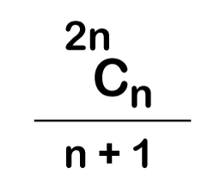

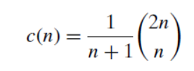

Dynamic Approach
Consider the below table, which contains the keys and frequencies.

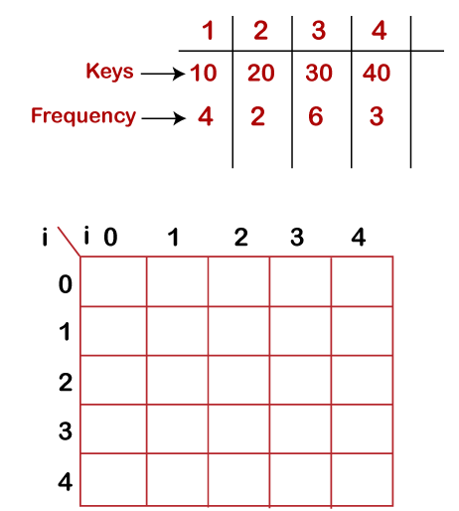

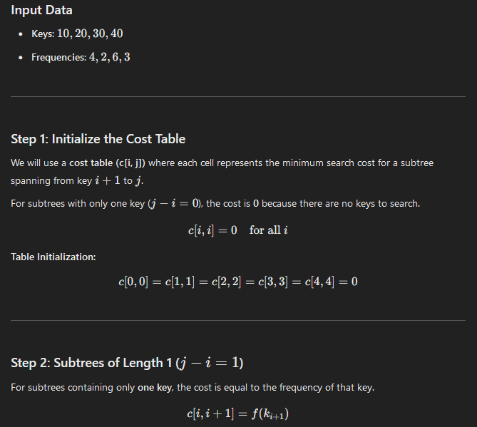

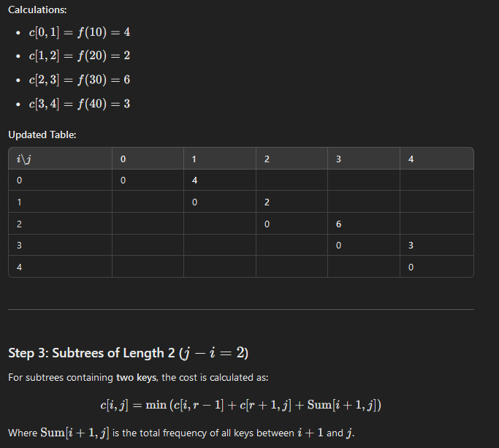
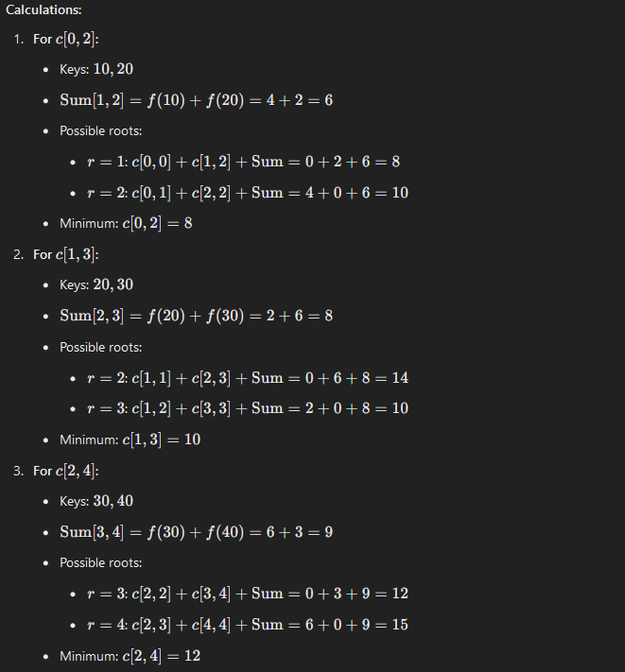
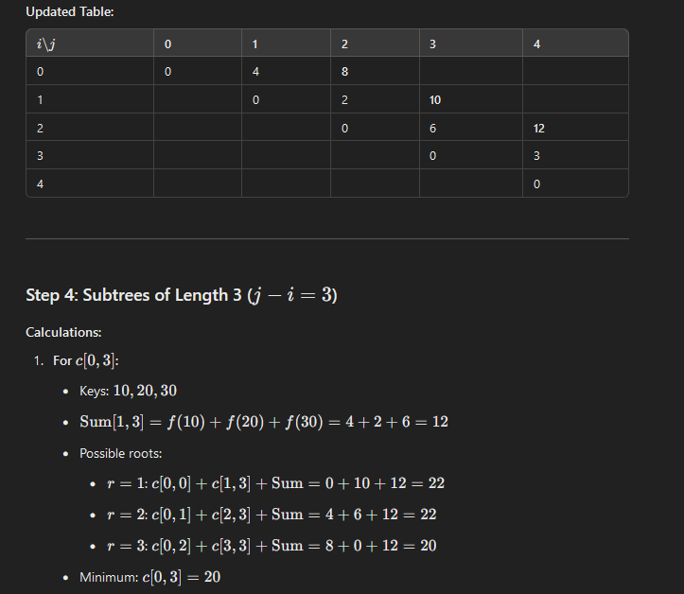

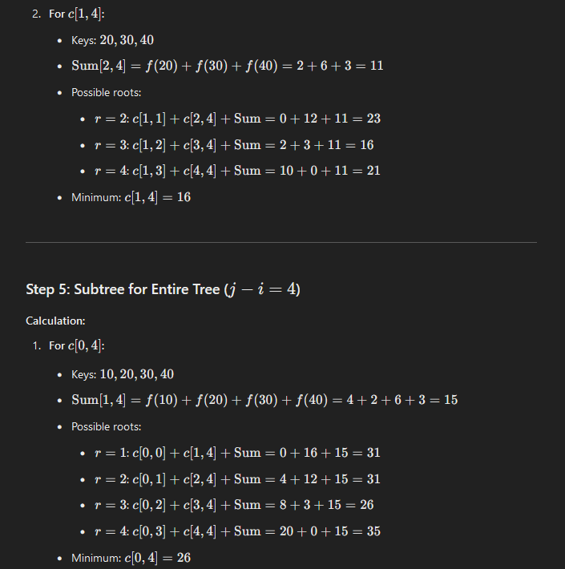

Final Result
The minimum cost of the OBST for the given keys is 26.

Q14 Explain Optimal Binary Tree Probability-Based Method.

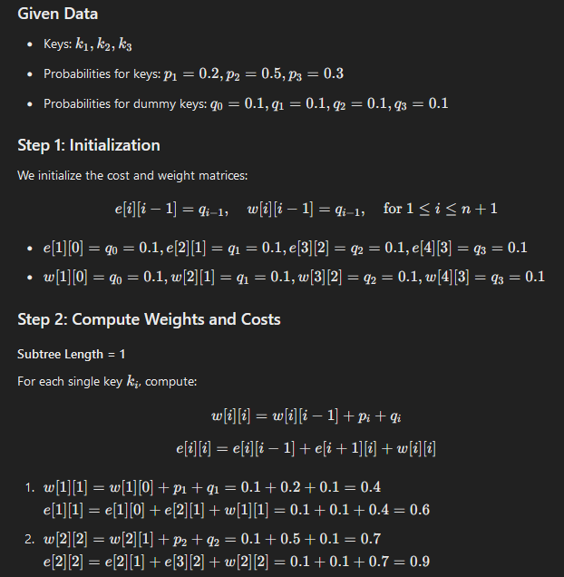

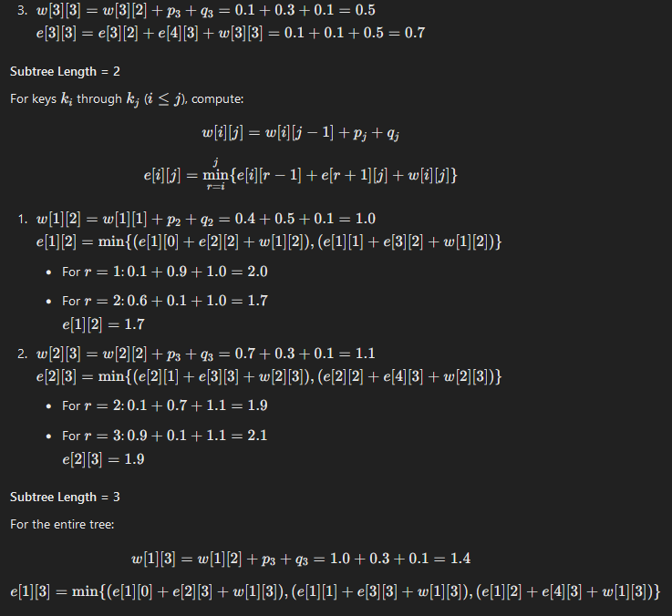
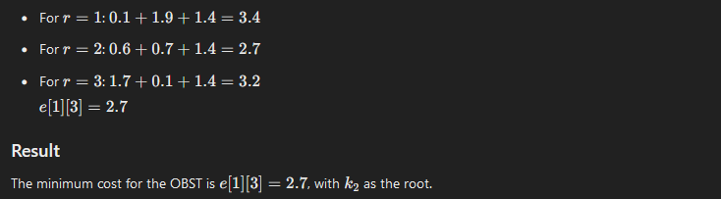
Q15. Explain 0/1 Knapsack Problem.

The 0/1 knapsack problem means that the items are either completely or no items are filled in a knapsack. For example, we have two items having weights 2kg and 3kg, respectively. If we pick the 2kg item then we cannot pick 1kg item from the 2kg item (item is not divisible); we have to pick the 2kg item completely. This is a 0/1 knapsack problem in which either we pick the item completely or we will pick that item. The 0/1 knapsack problem is solved by the dynamic programming.
Unlike in fractional knapsack, the items are always stored fully without using the fractional part of them. Its either the item is added to the knapsack or not. That is why, this method is known as the 0-1 Knapsack problem.
Hence, in case of 0-1 Knapsack, the value of xi can be either 0 or 1, where other constraints remain the same.
0-1 Knapsack cannot be solved by Greedy approach. Greedy approach does not ensure an optimal solution in this method. In many instances, Greedy approach may give an optimal solution.

0-1 Knapsack Algorithm
Problem Statement − A thief is robbing a store and can carry a maximal weight of W into his knapsack. There are n items and weight of ith item is wi and the profit of selecting this item is pi. What items should the thief take?
Let i be the highest-numbered item in an optimal solution S for W dollars. Then S’ = S − {i} is an optimal solution for W – wi dollars and the value to the solution S is Vi plus the value of the sub-problem.
We can express this fact in the following formula: define c[i, w] to be the solution for items 1,2, … , i and the maximum weight w.
The algorithm takes the following inputs
- The maximum weight W
- The number of items n
- The two sequences v = <v1, v2, …, vn> and w = <w1, w2, …, wn>
The set of items to take can be deduced from the table, starting at c[n, w] and tracing backwards where the optimal values came from.
If c[i, w] = c[i-1, w], then item i is not part of the solution, and we continue tracing with c[i-1, w]. Otherwise, item i is part of the solution, and we continue tracing with c [i-1, w-W].

Dynamic-0-1-knapsack (v, w, n, W)
for w = 0 to W do
c[0, w] = 0
for i = 1 to n do
c[i, 0] = 0
for w = 1 to W do
if wi ≤ w then
if vi + c[i-1, w-wi] then
c[i, w] = vi + c[i-1, w-wi]
else c[i, w] = c[i-1, w]
else
c[i, w] = c[i-1, w]

Example
Problem:
wi = {3, 4, 5, 6}
pi = {2, 3, 4, 1}
First,
we create a matrix shown as below:
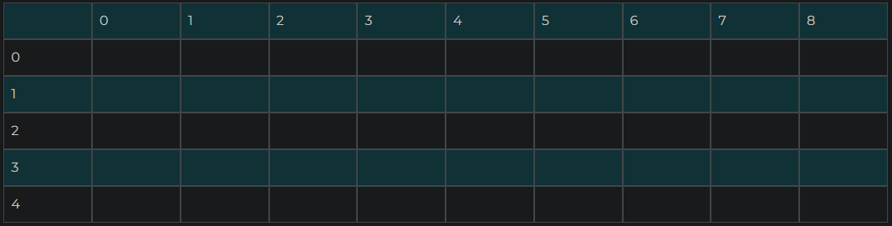
In the above matrix, columns represent the weight, i.e., 8. The rows represent the profits and weights of items. Here we have not taken the weight 8 directly, problem is divided into sub-problems, i.e., 0, 1, 2, 3, 4, 5, 6, 7, 8. The solution of the sub-problems would be saved in the cells and answer to the problem would be stored in the final cell. First, we write the weights in the ascending order and profits according to their weights shown as below:
wi = {3, 4, 5, 6}
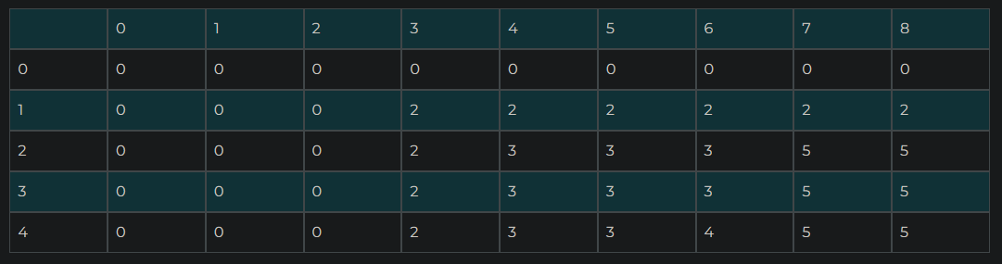
pi = {2, 3, 4, 1}
As we can observe in the above table that 5 is the maximum profit among all the entries. The pointer points to the last row and the last column having 5 value. Now we will compare 5 value with the previous row; if the previous row, i.e., i = 3 contains the same value 5 then the pointer will shift upwards. Since the previous row contains the value 5 so the pointer will be shifted upwards as shown in the below table:

Q16. Explain Travelling Salesman Problem using dynamic programming.

The Travelling Salesman Problem (also known as the Travelling Salesperson Problem or TSP) is an NP-hard graph computational problem where the salesman must visit all cities (denoted using vertices in a graph) given in a set just once. The distances (denoted using edges in the graph) between all these cities are known. We are requested to find the shortest possible route in which the salesman visits all the cities and returns to the origin city.

There is a difference between Hamiltonian Cycle and TSP. The Hamiltonian Cycle problem is the problem where we have to find if there exists a tour that visits every city accurately once. However, in this problem, we already know that Hamiltonian Tour exists as the graph is complete, and in fact, there exist many such tours. Therefore, the problem is to find a minimum weight Hamiltonian Cycle.

Travelling Salesman Dynamic Programming Algorithm
Let us consider a graph G = (V,E), where V is a set of cities and E is a set of weighted edges. An edge e(u, v) represents that vertices u and v are connected. Distance between vertex u and v is d(u, v), which should be non-negative.
Suppose we have started at city 1 and after visiting some cities now we are in city j. Hence, this is a partial tour. We certainly need to know j, since this will determine which cities are most convenient to visit next. We also need to know all the cities visited so far, so that we don't repeat any of them. Hence, this is an appropriate sub-problem.
For a subset of cities S ϵ {1,2,3,...,n} that includes 1, and j ϵ S, let C(S, j) be the length of the shortest path visiting each node in S exactly once, starting at 1 and ending at j.
When |S|> 1 , we define 𝑪C(S,1)= ∝
since the path cannot start and end at 1.
Now, let express C(S, j) in terms of smaller sub-problems. We need to start at 1 and end at j. We should select the next city in such a way that
C(S,j) = min C(S−{j},i)+d(i,j)where i ϵ S and i≠j

Algorithm: Traveling-Salesman-Problem
C ({1}, 1) = 0
for s = 2 to n do
for all subsets S є {1, 2, 3, … , n} of size s and containing 1
C (S, 1) = ∞
for all j є S and j ≠ 1
C (S, j) = min {C (S – {j}, i) + d(i, j) for i є S and i ≠ j}
Return minj C ({1, 2, 3, …, n}, j) + d(j, i)
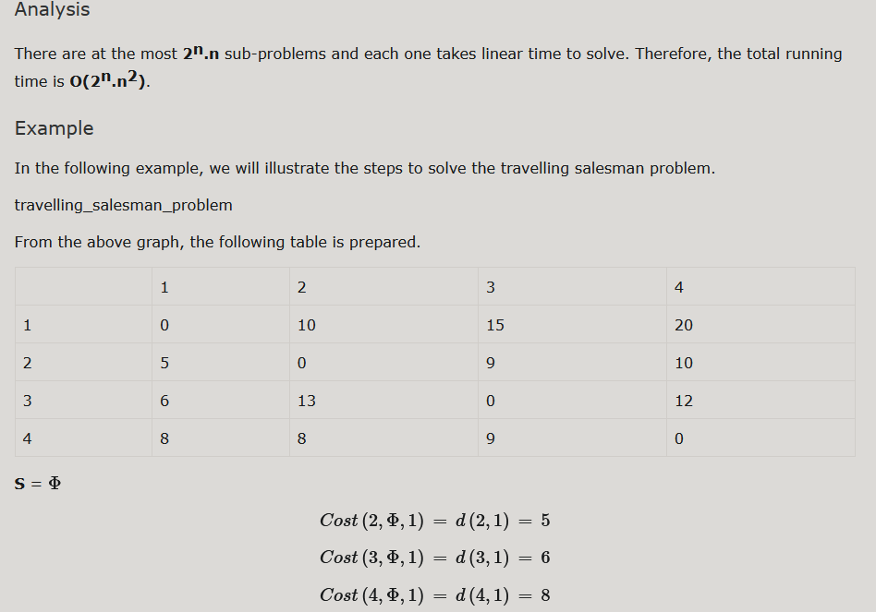
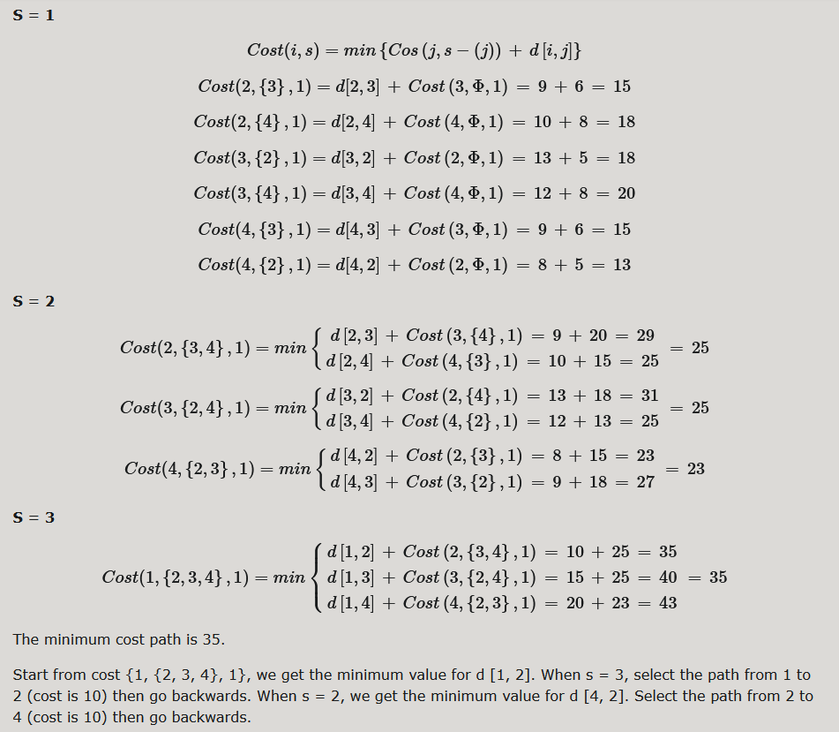
Q17. Explain Floyd-Warshall Algorithm.

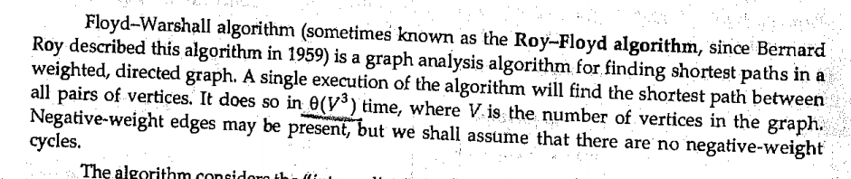
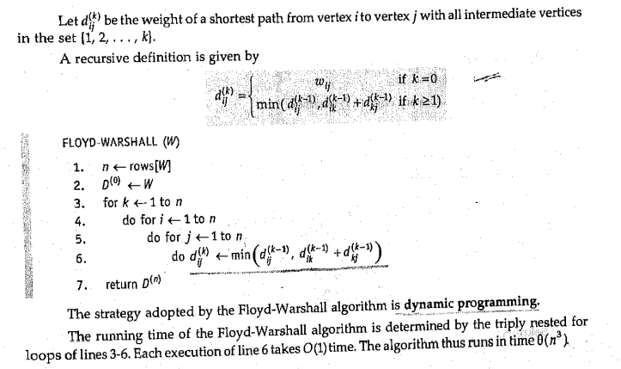
Q18.

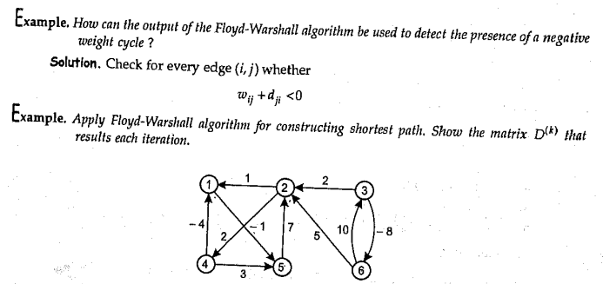

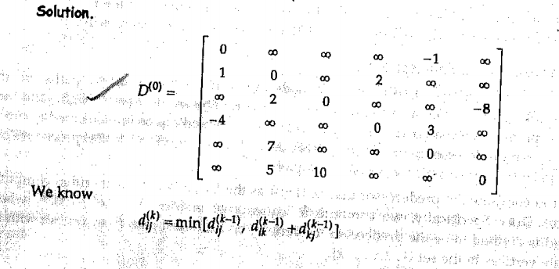

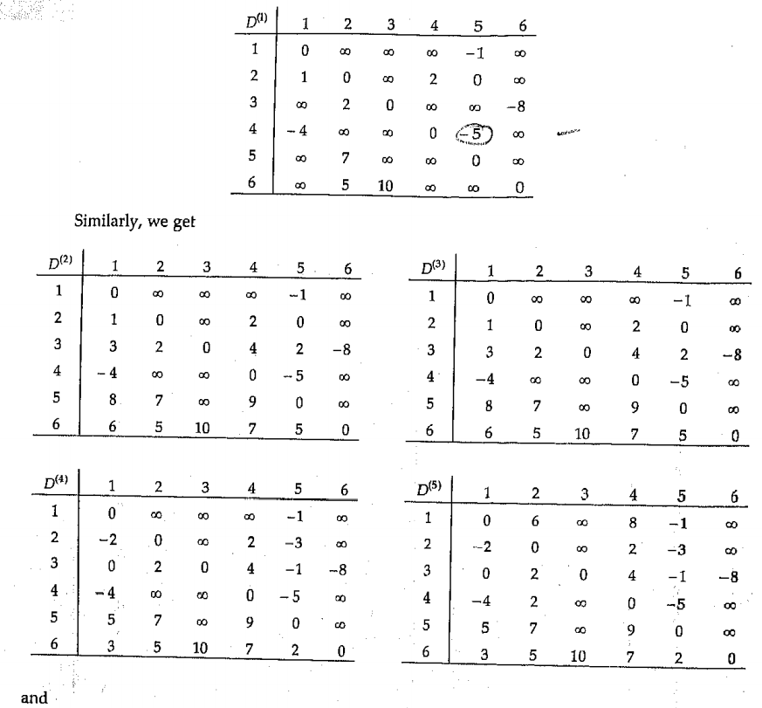
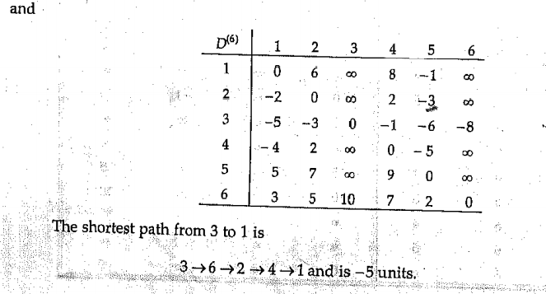
Q19. What is Branch and Bound?

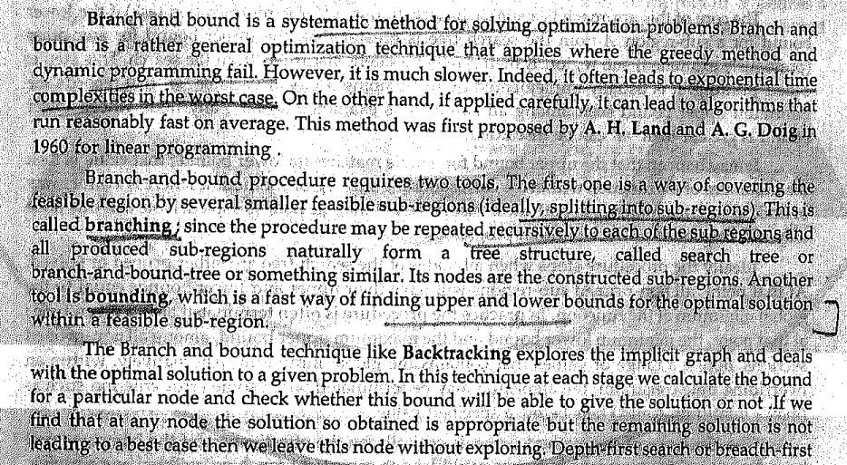
he Branch and Bound method is an algorithmic technique for solving optimization problems, particularly those with discrete or combinatorial solutions, such as Integer Programming, the Traveling Salesman Problem, and Knapsack Problem. It systematically explores the solution space by dividing it into smaller subproblems (branching) and using bounds to eliminate subproblems that cannot lead to optimal solutions.

Key Steps:
- Branching: Divide the problem into smaller subproblems to create a "branch" of possible solutions.
- Bounding: Compute an upper or lower bound for the objective function in each subproblem.
- Pruning: Eliminate subproblems that cannot produce a better solution than the best-known solution (current optimal).

Characteristics:
- It uses a tree structure, where the root represents the original problem and branches represent subproblems.
- The method ensures that the entire solution space is searched, but unnecessary branches are avoided, improving efficiency.
- It guarantees finding an optimal solution if one exists.

Q20 Where are Branch and Bound method applied?
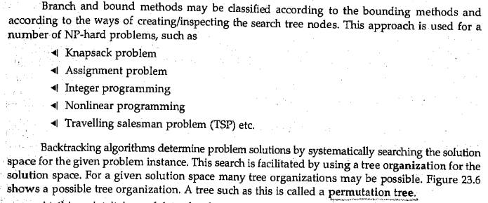

Q21. What is Live Node, Dead Node and Bounding Functions?
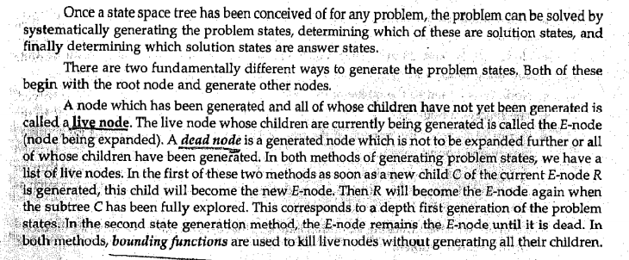

Q22. Explain FIFO Branch and Bound Algorithm.

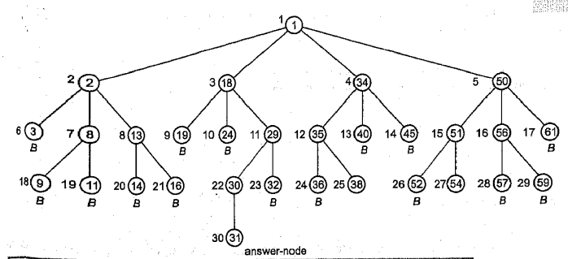

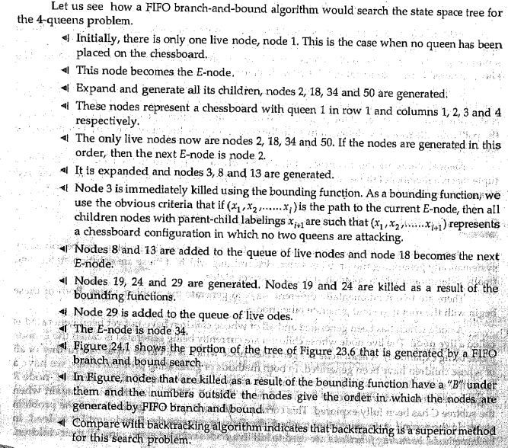

Q23. Explain TSP using branch and bound method.

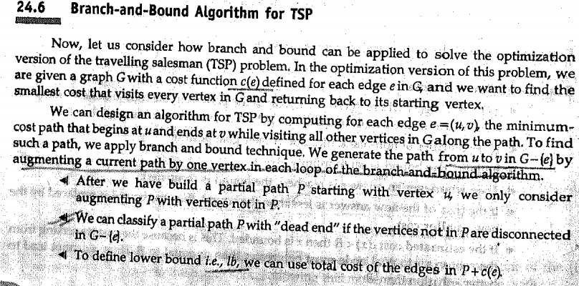

Steps in BAB for TSP:
- Represent the Problem: Represent TSP as a graph where nodes are cities, and edges are distances or costs.
- Initialize:
  - Start with a reduced cost matrix where the smallest value in each row and column is subtracted from all elements in that row/column.
  - This reduction gives a lower bound for the cost of visiting all cities.
- Branching:
  - Select the current node (city) and explore all possible "branches" (next cities).
  - For each branch, compute a new reduced cost matrix by:
    - Setting the row of the current city and the column of the next city to infinity.
    - Removing the possibility of revisiting the current city.
- Bounding:
  - Calculate a new lower bound for the current branch by reducing the updated cost matrix.
  - Add the edge's cost to the lower bound.
- Pruning:
  - Compare the lower bound of each branch with the best-known solution:
    - Discard branches with a lower bound greater than or equal to the best solution.
    - Keep branches with a lower bound smaller than the best solution for further exploration.
- Repeat:
  - Continue branching, bounding, and pruning until all cities are visited and the complete solution (tour) is found.
  - The branch with the smallest cost at the leaf node is the optimal solution.
- Optimal Tour:
  - Track the sequence of cities and the total cost of the optimal path.

Example (Simplified):
Given a distance matrix:
A B C D
A ∞ 10 15 20
B 10 ∞ 35 25
C 15 35 ∞ 30
D 20 25 30 ∞
- Start at A. Compute the reduced cost matrix and its lower bound.
- Branch to possible next cities (B, C, D), updating the matrix and bounds.
- Prune branches with bounds exceeding the best-known solution.
- Continue until all cities are visited.

Q24. Explain Knapsack Problem with Branch and Bound.
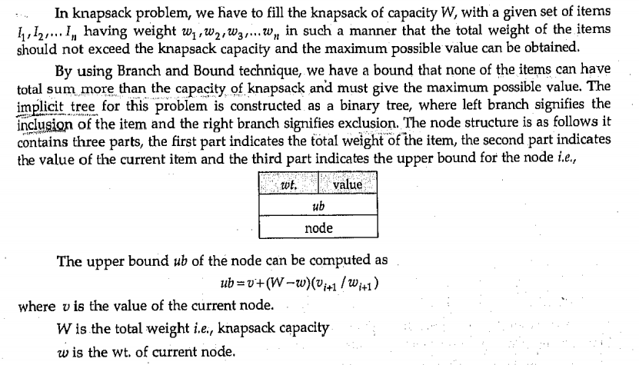

Q25.

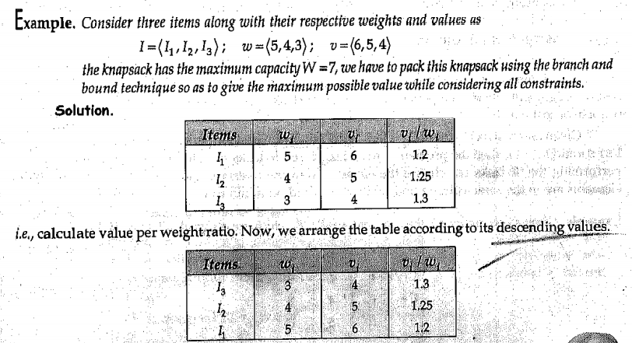
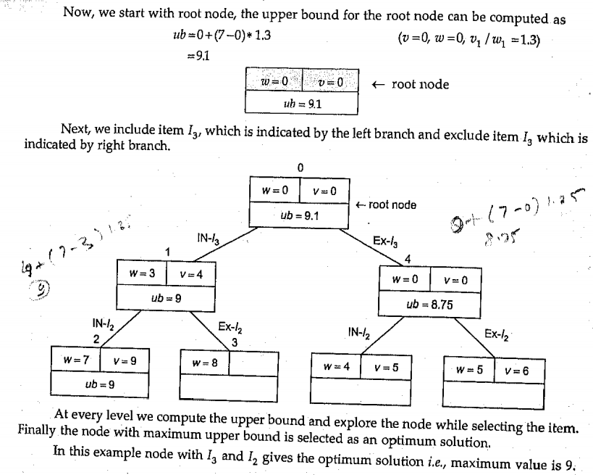

Unit – 4 (DAA)

Q1. Explain the Native String-matching algorithm.

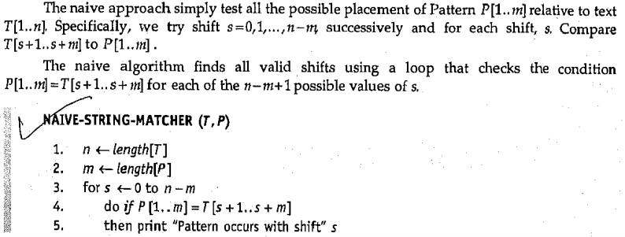
Q2. Explain The Rabin-Karp Algorithm.

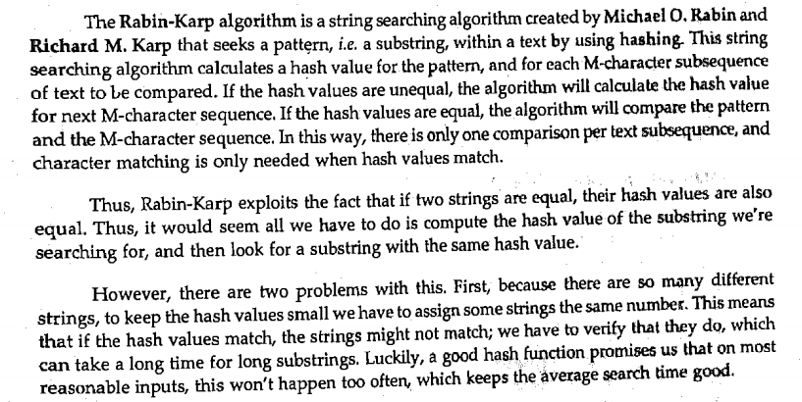
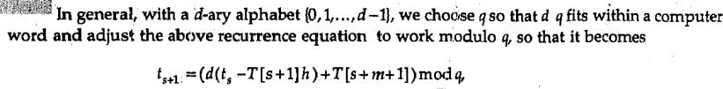

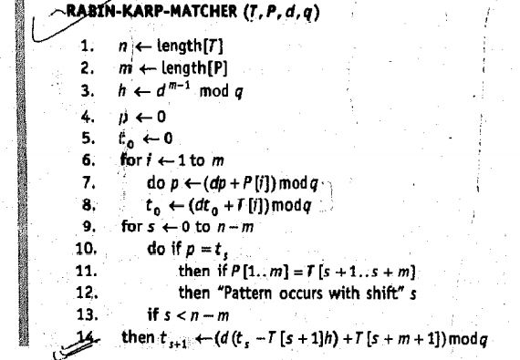

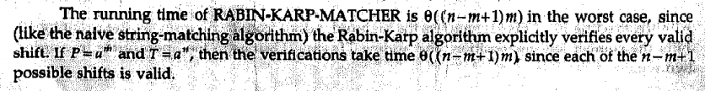
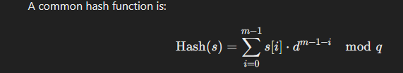

Q3. For string matching working module q=11, how many spurious hits does the Rabin-karp matcher encounter in the text T = 3141592653589793, when looking for the pattern P=26?

To determine the number of spurious hits the Rabin-Karp matcher encounters, we need to compute the hash values of the pattern P=26P = 26P=26 and all substrings of T=3141592653589793T = 3141592653589793T=3141592653589793 of the same length as PPP, then compare these hash values.

Definitions:
- Text T=3141592653589793T = 3141592653589793T=3141592653589793, length n=16n = 16n=16.
- Pattern P=26P = 26P=26, length m=2m = 2m=2.
- q=11q = 11q=11, a prime number used for modulo operation.
- Spurious hit: When two hash values match, but the substrings do not.
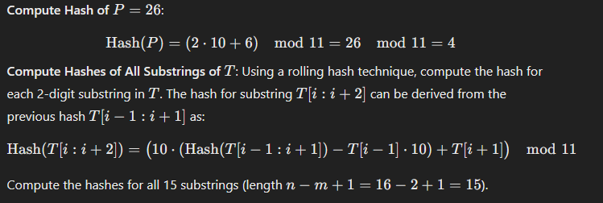
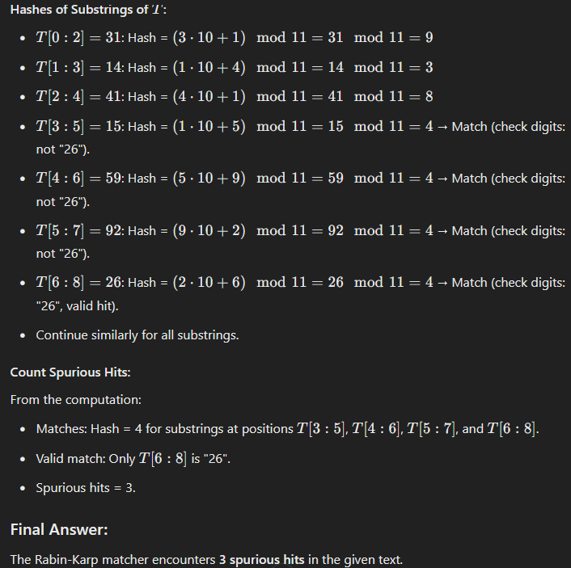

Q4. Explain String-matching with Finite Automata.
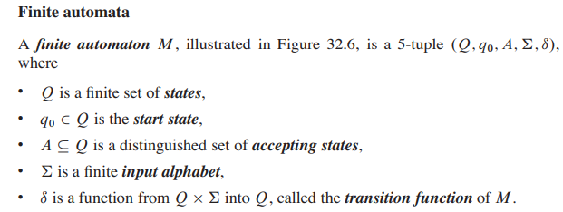
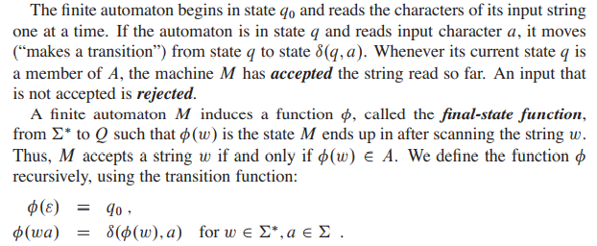

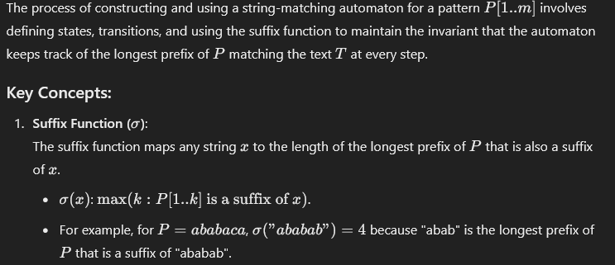

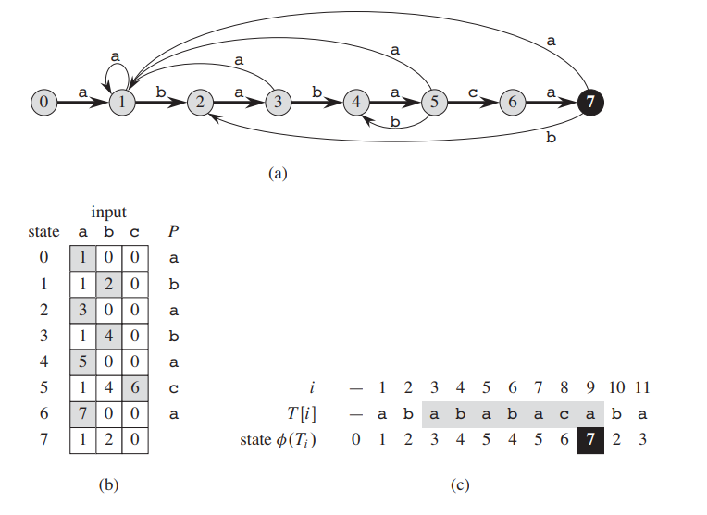
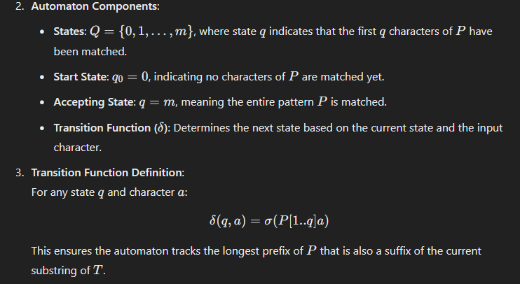

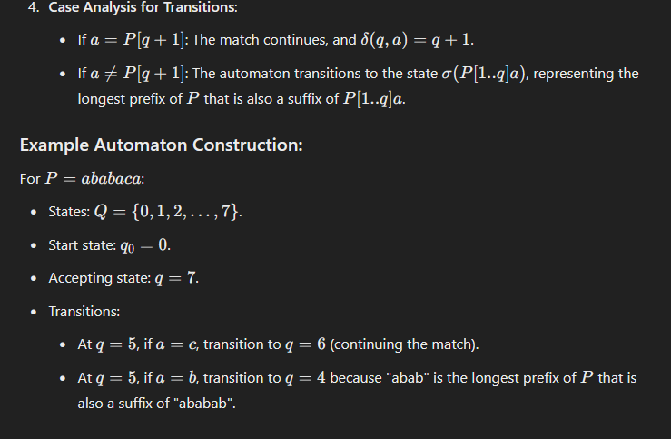
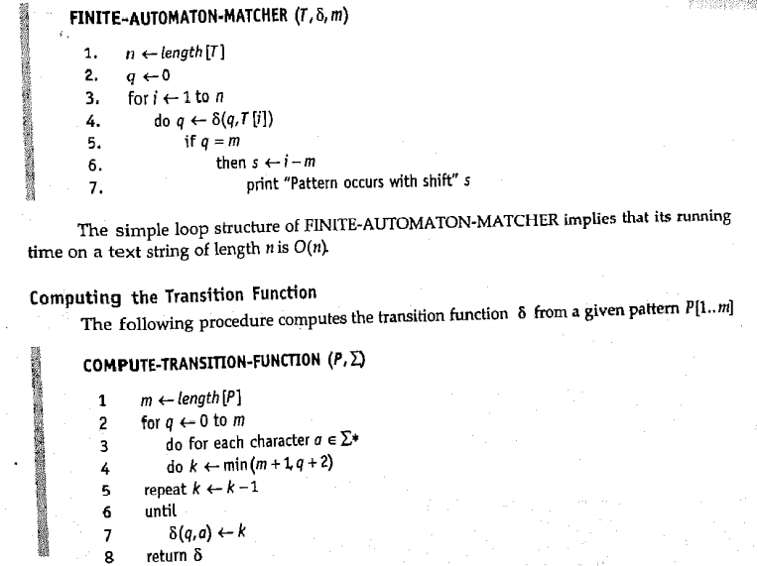
Q5. Explain Knuth Morris Pratt (KMP) Algorithm.
The KMP algorithm avoids re-checking characters of the text that have already been matched by preprocessing the pattern to build a "failure function" or LPS array. This array tells us how far to shift the pattern without missing any potential matches.
The LPS array is the core of KMP. For a given pattern, the LPS array stores the length of the longest prefix of the pattern that is also a suffix for every index. This information is used to determine how far to shift the pattern after a mismatch.

How it works:
- For a given position i in the pattern:
  - The LPS value at i is the length of the longest prefix of the pattern that matches a suffix ending at i−1.
- Example: Pattern: "ABABCABAB"
LPS Array: [0, 0, 1, 2, 0, 1, 2, 3, 4]

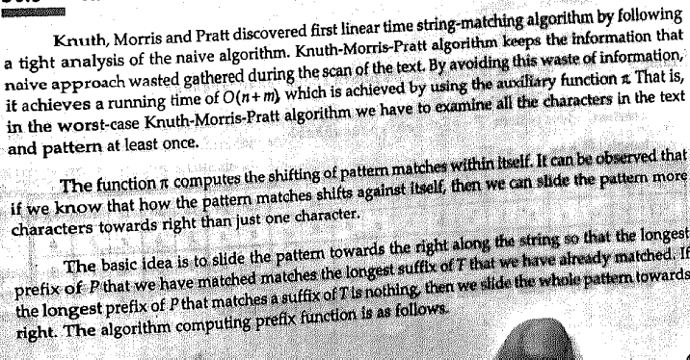
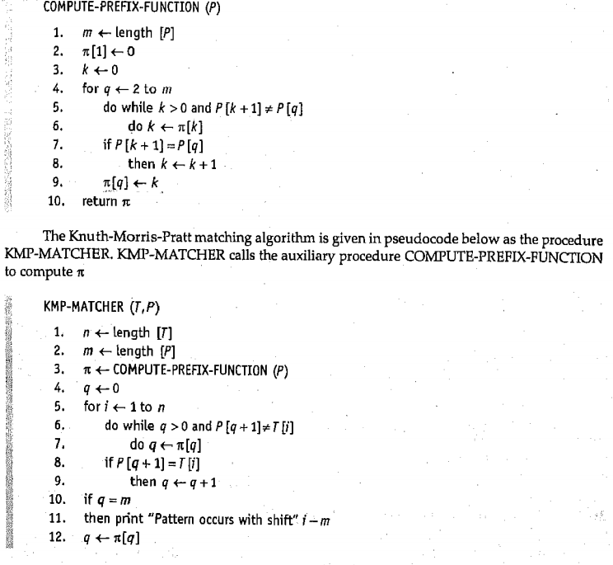

Q6.
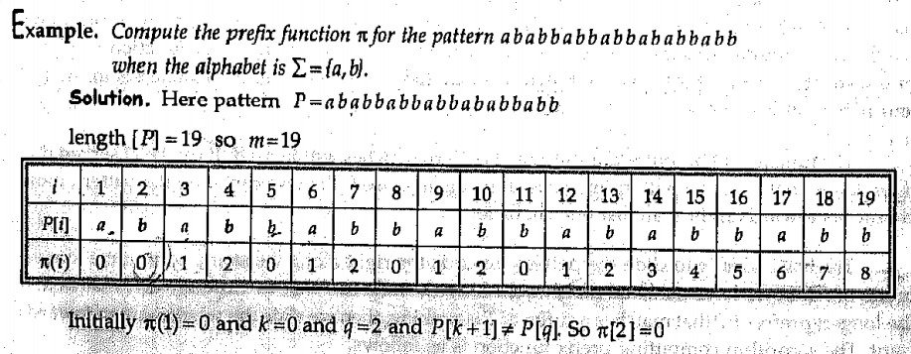
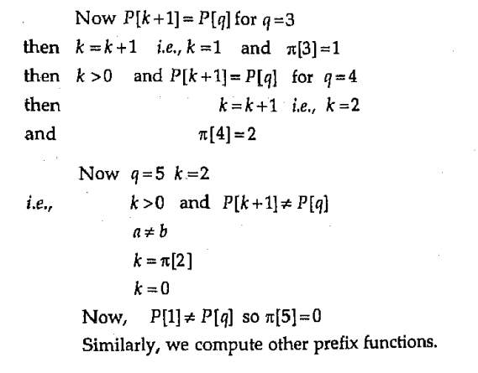

Q7. What is Complexity Theory?
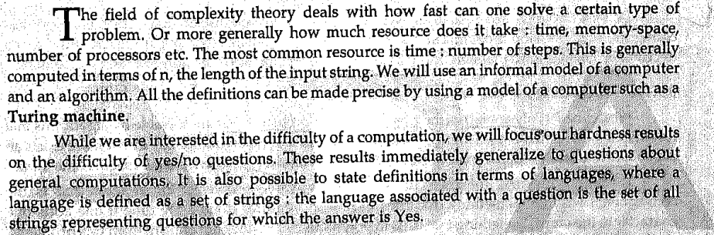
Q8. What are the different classes of problem?
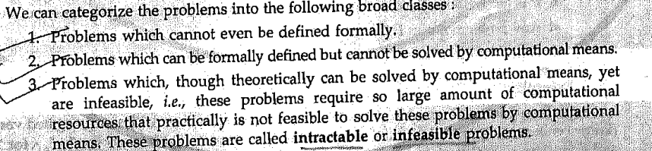
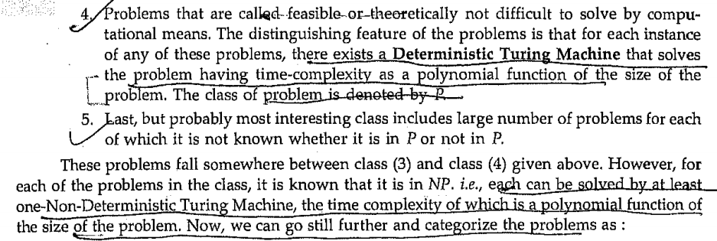
P (Polynomial time): These are decision problems that can be solved by a deterministic Turing machine in polynomial time. Examples include sorting a list, finding the shortest path in a graph, etc.
NP (Nondeterministic Polynomial time): These are decision problems for which a solution can be verified in polynomial time by a deterministic Turing machine, even if finding the solution may take longer. Examples include the traveling salesman problem and the satisfiability problem (SAT).
Q9. What are decision problems?
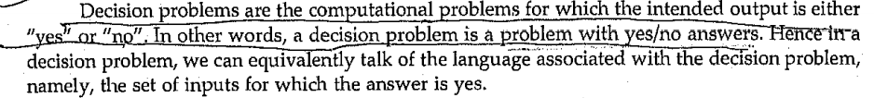
Q10. Optimization problem vs decision problem?
Q11. Define P Class.
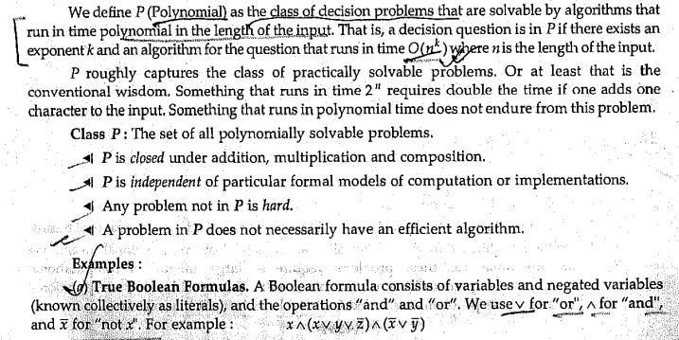
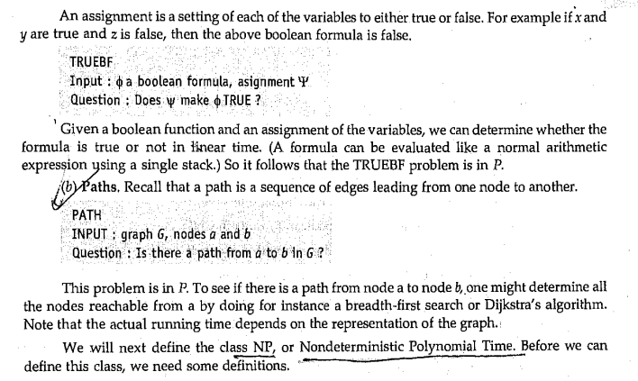
Q12. Explain Verification Algorithm.
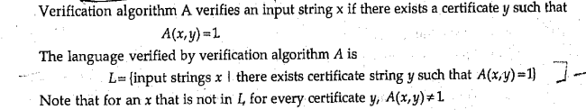
Q13. Explain Polynomial-time verification algorithm.
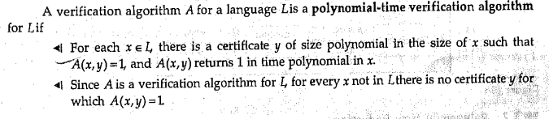
Q14. Define NP Class.
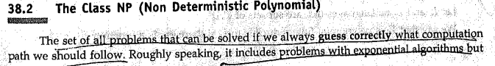
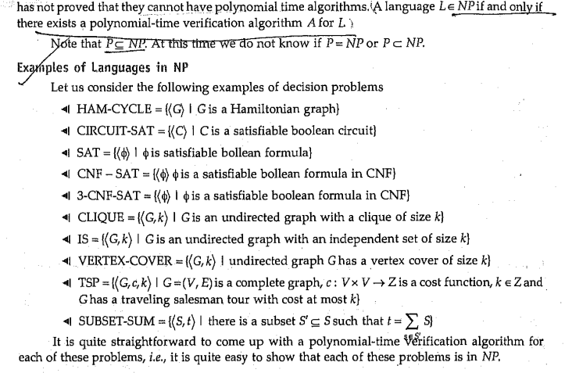

Q15. What is reduction?
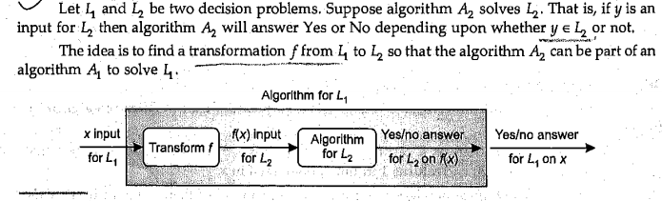
Q16. Show Polynomial-time Reduction.
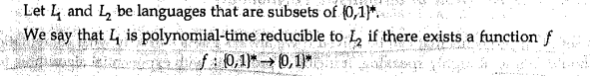
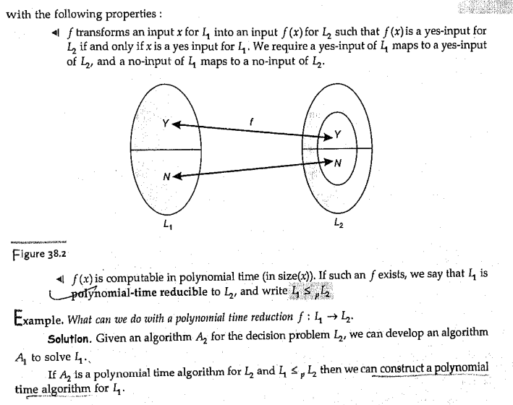

Q17.
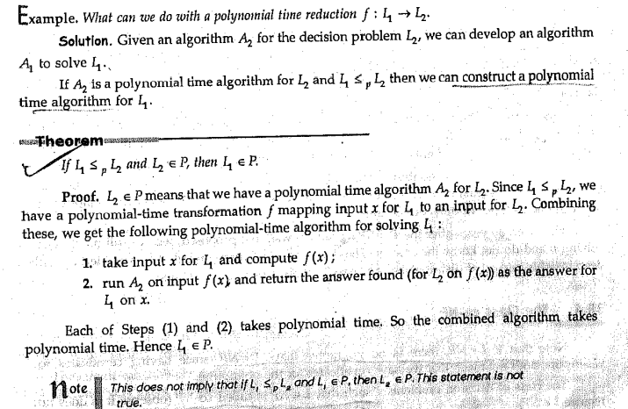
Q18 What is NP Completeness?
NP-Complete problems are a special class of problems in computational complexity that are both in NP and as "hard" as any problem in NP. They are significant because solving one NP-complete problem in polynomial time would imply that all NP problems can also be solved in polynomial time.
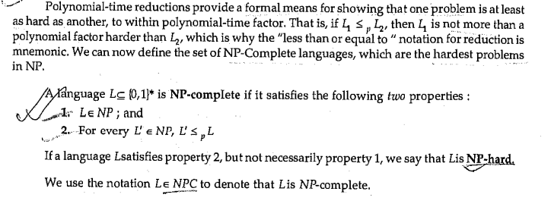
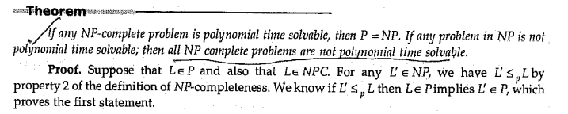

Q19. When is P=NP?
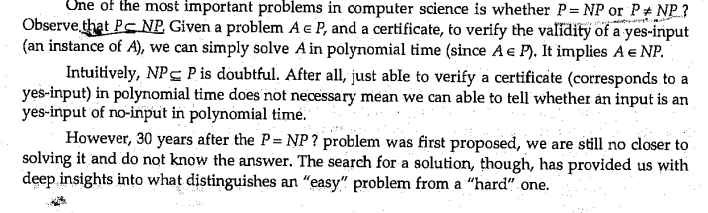
Q20. Define Class co-NP?
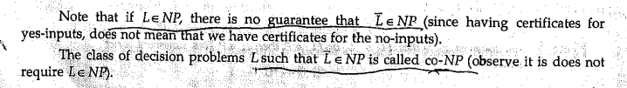
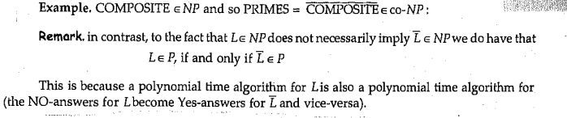
Q21. What is Satisfiability (SAT)?
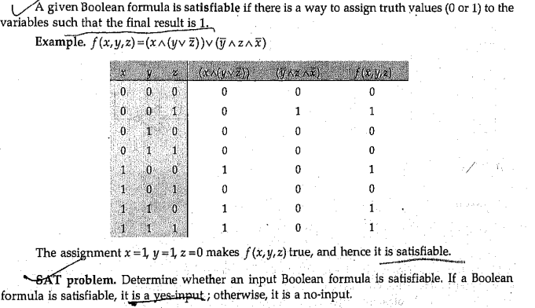
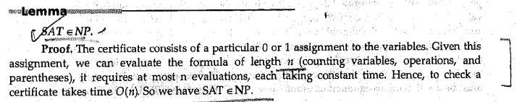
Q22. What is Circuit Satisfiability (CIRCUIT-SAT)?
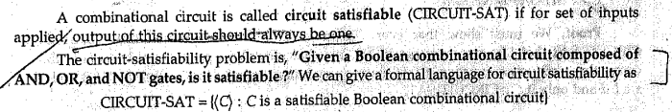
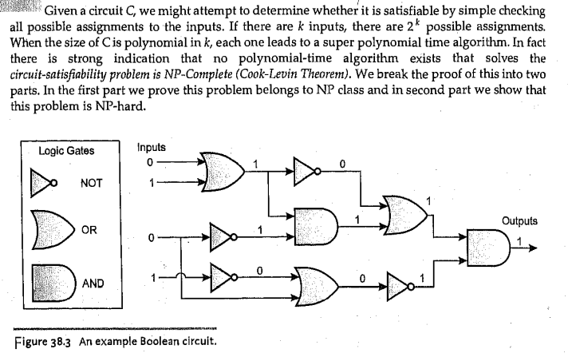
Q23. Prove CIRCUIT-SAT is NP and NP-hard.

Step 1: CIRCUIT-SAT is in NP
CIRCUIT-SAT Definition: Given a Boolean circuit made up of logic gates, determine if there exists an input assignment of variables that makes the output of the circuit evaluate to true.
- Verification: If a satisfying assignment is provided, it is straightforward to verify in polynomial time. By substituting the assignment into the circuit and evaluating it gate-by-gate, we can determine whether the output is true in polynomial time.
- Conclusion: Since verifying a solution is polynomial, CIRCUIT-SAT is in NP.
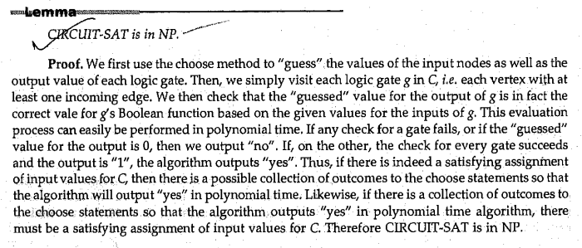

Step 2: CIRCUIT-SAT is NP-hard
To prove CIRCUIT-SAT is NP-hard, we show that any problem in NP can be reduced to CIRCUIT-SAT in polynomial time.
- Any Problem in NP Can Be Represented by a Turing Machine:
  - A problem in NP can be solved by a nondeterministic Turing machine (NTM) in polynomial time.
  - For an input of size nnn, the NTM performs a series of computations on the input using a polynomial number of steps p(n)p(n)p(n).
- Simulation of the Turing Machine:
  - Each step of the Turing machine (e.g., reading, writing, moving) can be represented by a Boolean circuit.
  - By combining circuits for each step of the Turing machine, we can construct a Boolean circuit that simulates the entire computation of the Turing machine.
- Reduction to CIRCUIT-SAT:
  - If the Turing machine accepts an input, there exists an assignment to the circuit that makes it output true.
  - Thus, deciding whether the Turing machine accepts an input is equivalent to solving CIRCUIT-SAT for the corresponding circuit.
- Polynomial-Time Construction:
  - The Boolean circuit for the Turing machine can be constructed in polynomial time relative to the size of the Turing machine and input.
- Conclusion: Since any problem in NP can be reduced to CIRCUIT-SAT in polynomial time, CIRCUIT-SAT is NP-hard.

Q24. Explain Methods of Proving NP-Complete problems.
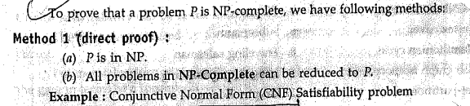
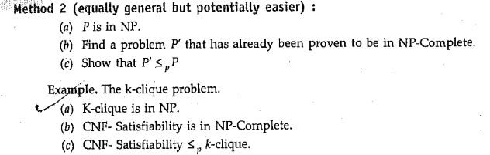
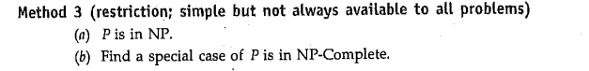
Q25. What are the techniques for dealing with NP-complete problem.
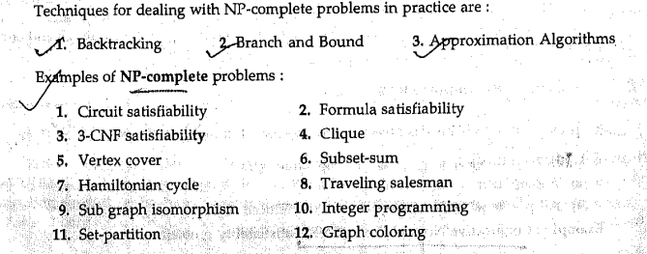
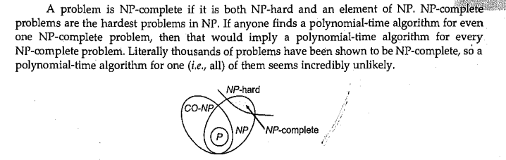

Q26. What is Formula Satisfiability?
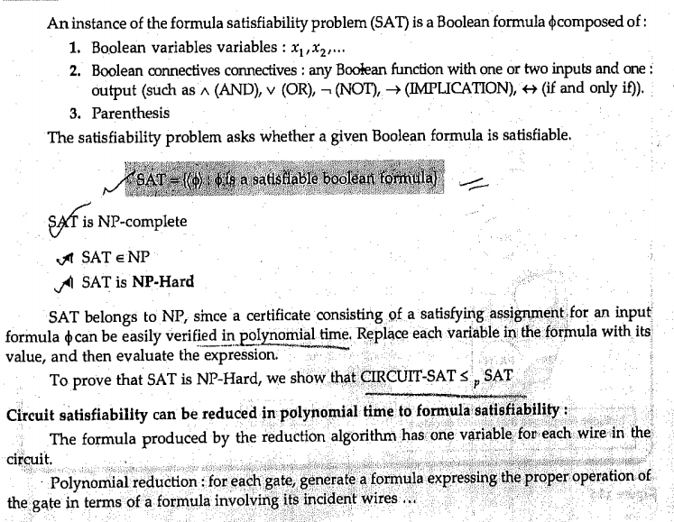
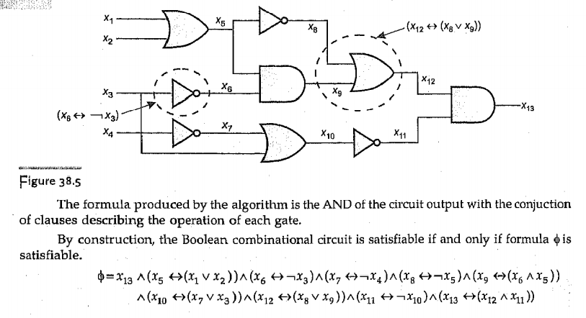

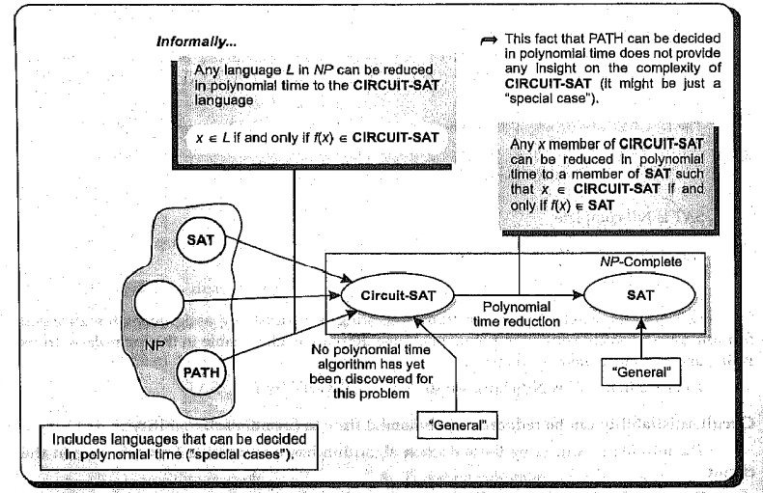
Q27. Do 3-CNF Satisfiability.
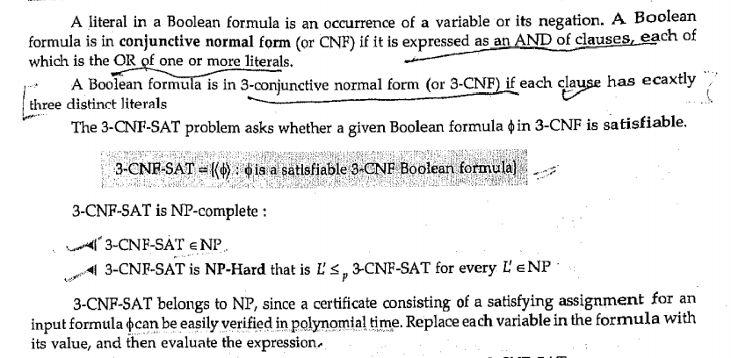
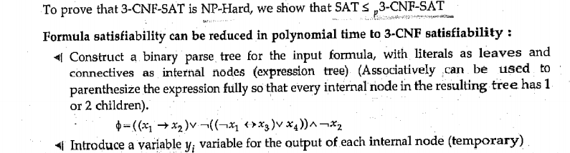

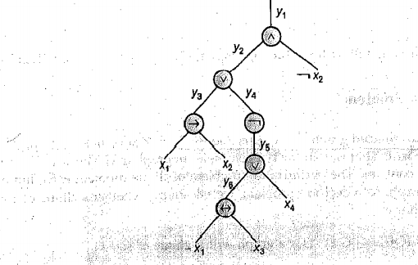

Q28. What is Vertex-cover Problem? How it is NP-Complete?
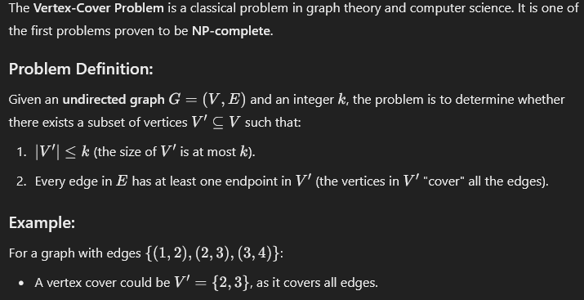
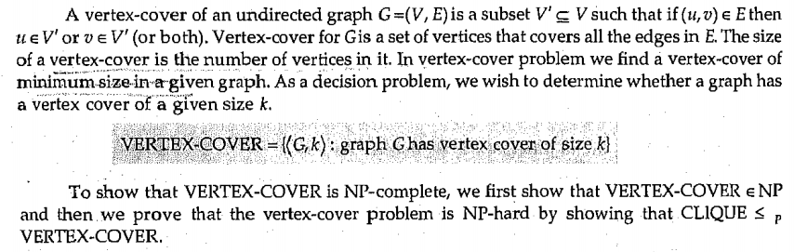

Q29. Explain Subset-Sum Problem?
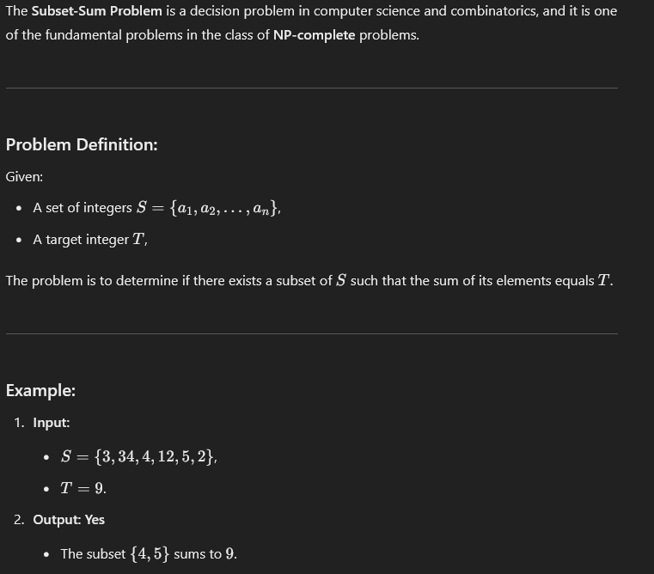
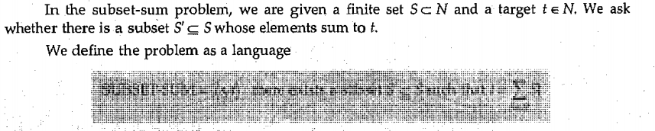
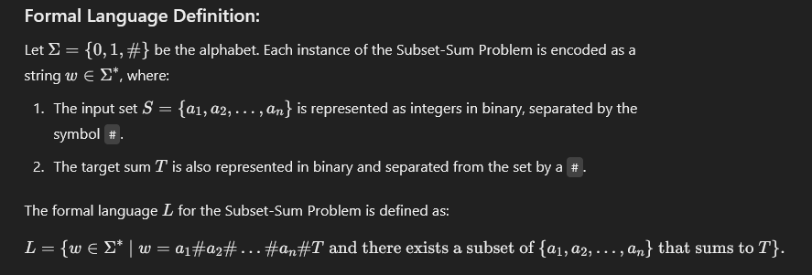

Q30 Explain Hamilton-Cycle Problem in NP-complete.
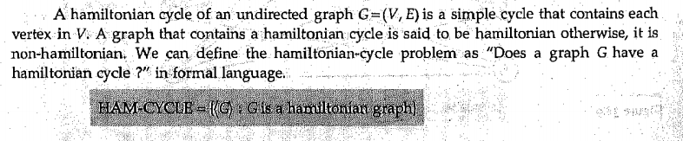
Q31. Show TSP is NP-Complete.
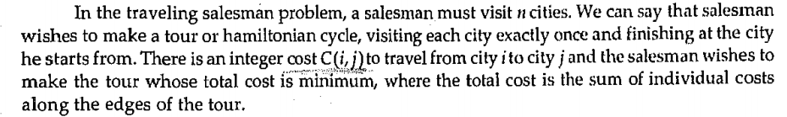
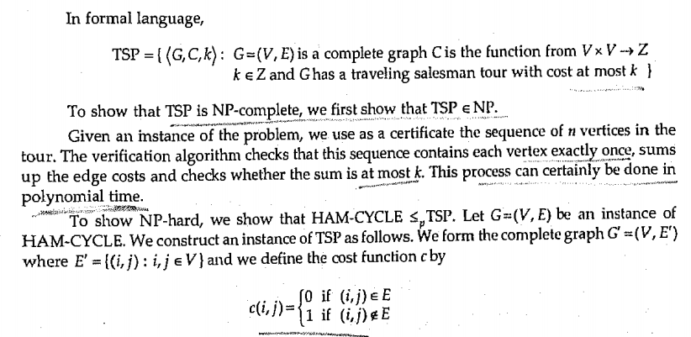
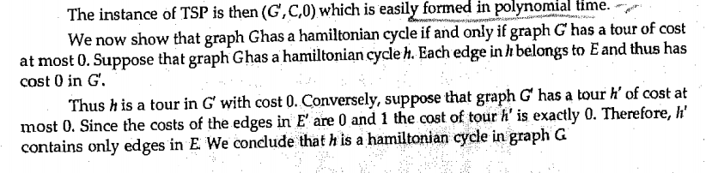

Q32. What is Flow Network? Explain its properties?
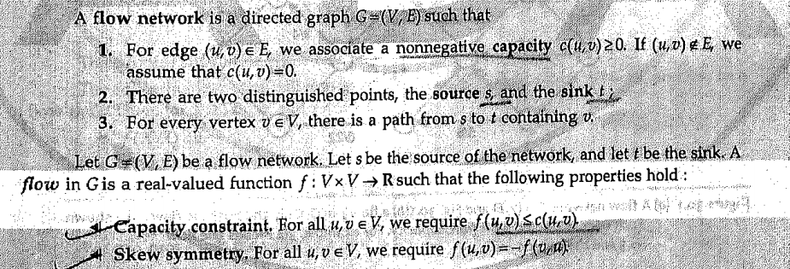
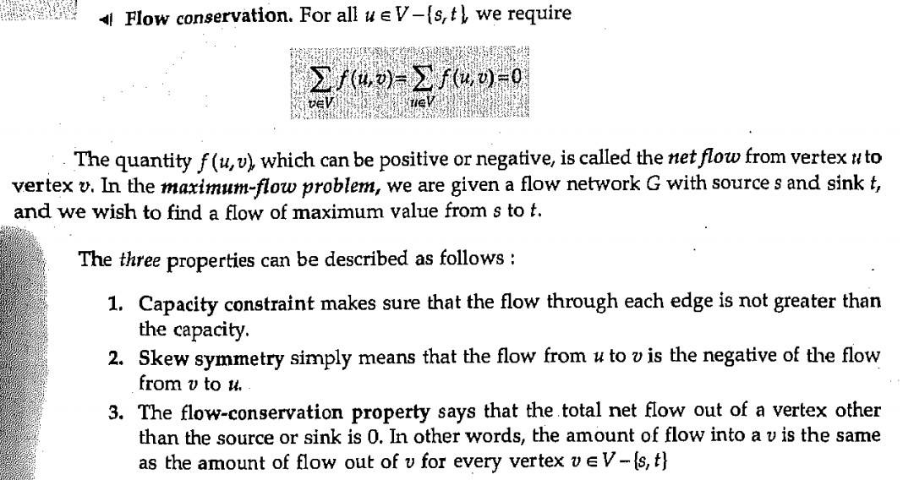
Q33. What is Implicit Summation notation?
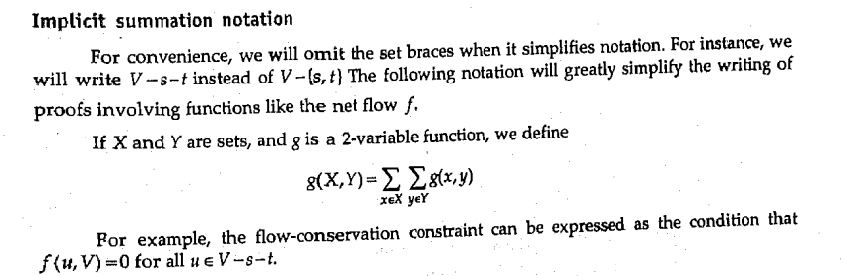
Q34. What are the Network Flow Problems?

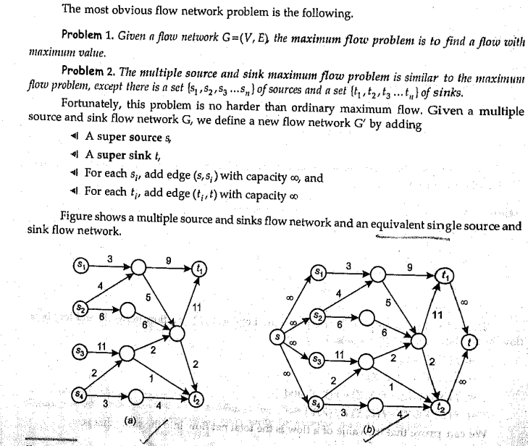
Q35. What is Residual Network?
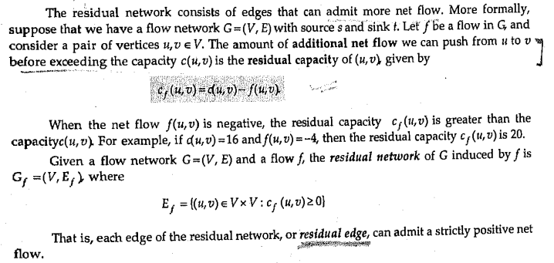
Q36. What is Augmenting Path?

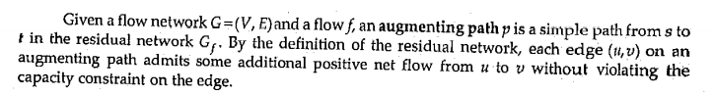
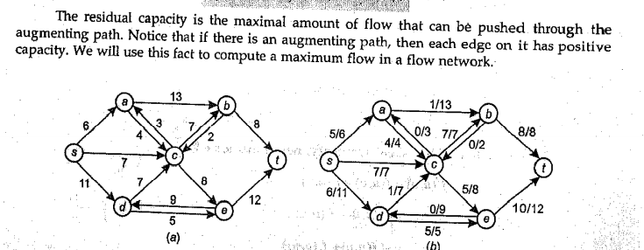
Q37. Explain Max-Flow min-cut theorem.
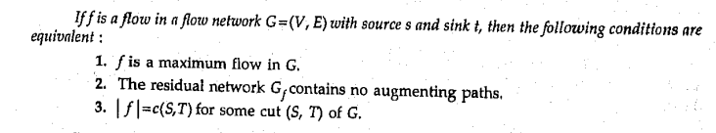
Q38. Explain Ford-Fulkerson Algorithm.
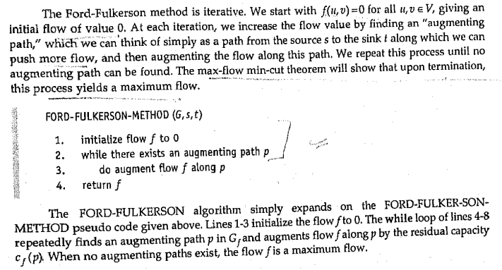

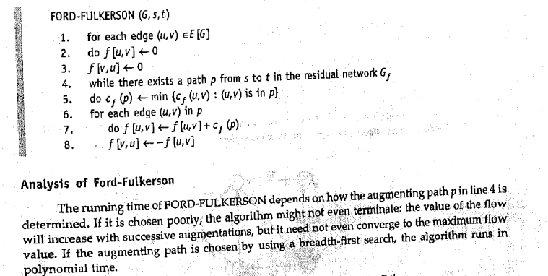
Q39.
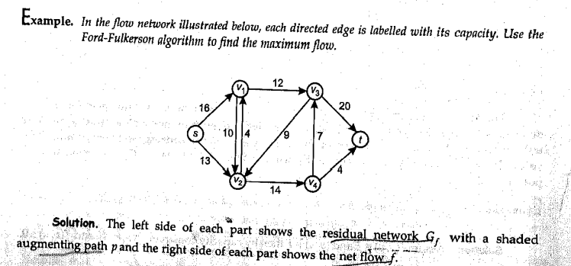
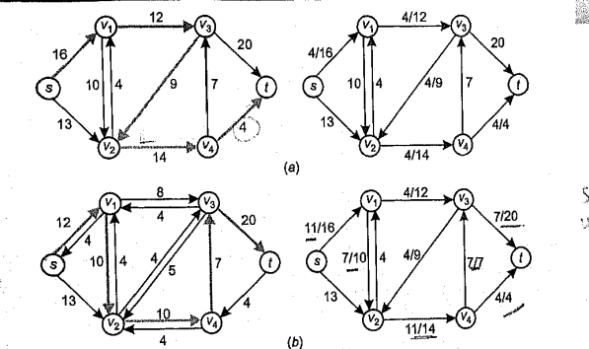
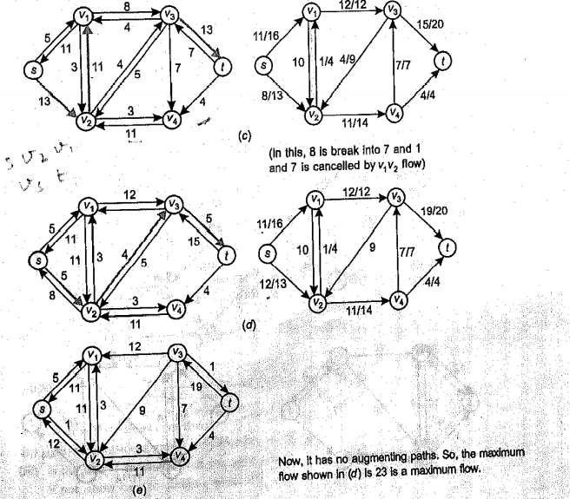
Q40.

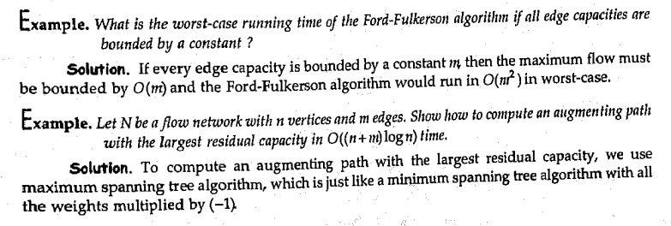

Q41. What is a Comparison Network? What is a Comparator?
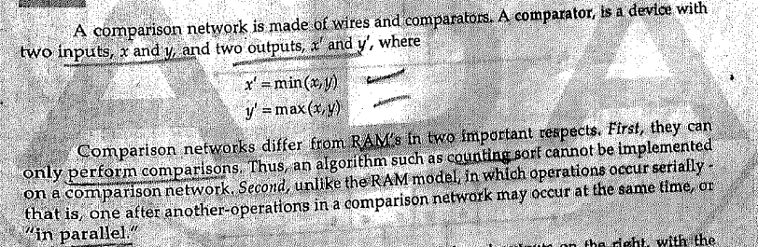
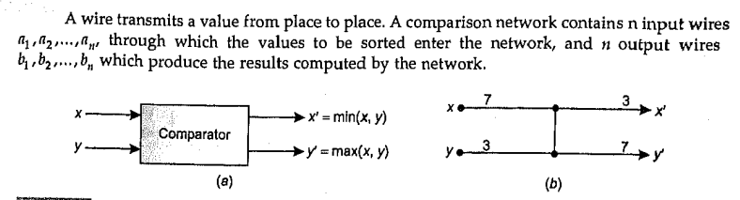
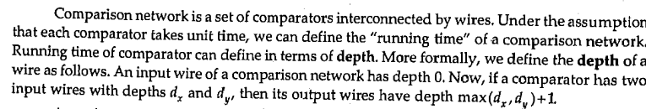
Q42. What is Sorting Network?
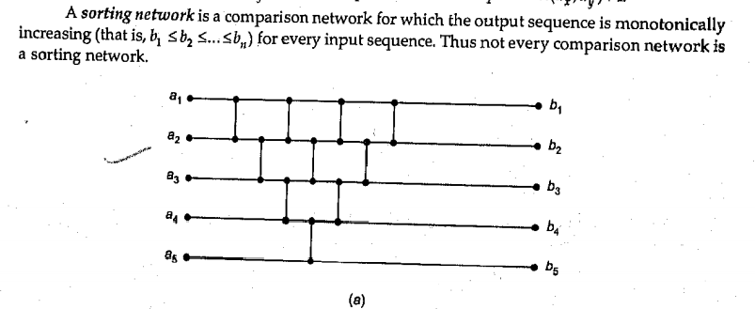

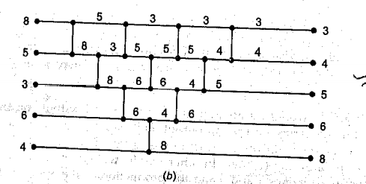

Q43. Explain Zero-One Principle.
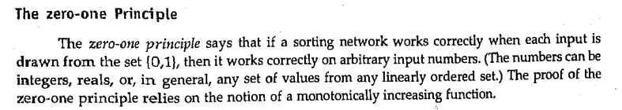
Q44. What is Bitonic Sorting Network?
Bitonic Sort is a classic parallel algorithm for sorting.
- The number of comparisons done by Bitonic sort is more than popular sorting algorithms like Merge Sort [ does O(log N) comparisons], but Bitonic sort is better for parallel implementation because we always compare elements in a predefined sequence and the sequence of comparison doesn’t depend on data. Therefore it is suitable for implementation in hardware and parallel processor array.
- Bitonic Sort can only be done if the number of elements to sort is 2^n. The procedure of bitonic sequence fails if the number of elements is not in the aforementioned quantity precisely.
A sequence is called Bitonic if it is first increasing, then decreasing. In other words, an array arr[0..n-i] is Bitonic if there exists an index I, where 0<=i<=n-1 such that
x0 <= x1 …..<= xi
and
xi >= xi+1….. >= xn-1
- A sequence, sorted in increasing order is considered Bitonic with the decreasing part as empty. Similarly, decreasing order sequence is considered Bitonic with the increasing part as empty.
- A rotation of the Bitonic Sequence is also bitonic.
Example:
Convert the following sequence to a bitonic sequence: 3, 7, 4, 8, 6, 2, 1, 5

Q45. What is Merging Network?


